### JAVA SWING BASED MEDICARE (HOSPITAL MANAGEMENT SYSTEM) - SQL CONNECTIVITY USING JDBC

*A*

*Report*

*Submitted in partial fulfilment of the Requirements for the award of the Degree of*

#### BACHELOR OF ENGINEERING

IN

**INFORMATION TECHNOLOGY**

By

**N. Charvee Krishna <1602-19-737-078>**

**Under the Guidance of**

**B. Leelavathy**



#### Department of Information Technology Vasavi College of Engineering (Autonomous) (Affiliated to Osmania University) Ibrahimbagh, Hyderabad-31

**2019-2020**

BONAFIDE CERTIFICATE

This to Certify that the project report titled

“***MEDICARE***”

project work of **N.Charvee Krishna** bearing Roll.no:**1602-19-737-078** who carried out this

project under my supervision in the IV semester for the academic year 2020-2021.

Signature Signature

external examiner internal examiner

ABSTRACT

The Health care management System is developed to decrease the work that is done manually at Hospital centres. Every single step is done with the help of system, services such as person appointments , insurance, bills are updated into the database , as well as reports of patient.

This Health management System will help in reducing lots of paper work and file work in these hospitals which will make easy management of hospital. It will also provide all the conditions of the patients including the diagnosis and what all care and medicines they should take timely .We can also know the doctors with different specialisation in different medical fields

The site has an administrator who keeps an eye on the overall functioning of the system. The system entitled “MEDICARE” is application software, which aims at providing services to the patients and providing them with an option of viewing they reports, observations and bills by themselves.

**REQUIREMENT ANALYSIS**

LIST OF TABLES:

* Appointment
* Patient
* Insurance
* Bill
* Services
* Employee
* Doctor
* Receptionist

LIST OF ATTRIBUTES AND THEIR DOMAIN TYPES:

* Appointment :
  + - Appointment ID : a_id - NUMBER
    - Patient ID : p_id - NUMBER
    - Date of Appointment : day - DATE
    - Record ID : r_id - NUMBER
* Patient :
  + - Patient ID : p_id : NUMBER
    - Name Of the Patient : name : VARCHAR(20)
    - Address Of the Patient : address : VARCHAR(100)
    - Age Of the Patient : age : NUMBER
    - Sex : sex - VARCHAR (10)
    - Phone Number Of the Patient : phone_no - NUMBER
* Insurance
  + - Insurance Type : type - VARCHAR2(10)
    - Inurance ID : i_id - NUMBER
    - Validity Of Insurance : validity - DATE
* Bill
  + - Total Bill Amount : amount - NUMBER
    - Bill ID : bill_id - NUMBER
    - Bill Issued Date : day : DATE
    - Bill Description : description : VARCHAR (50))
* Services
  + - Service ID : s_id - NUMBER
    - Report Issue : report - VARCHAR (100)
    - Date Of Issue : day - DATE
* Employee
  + - Employee ID : emp_id - NUMBER
    - Phone Number Of The Employee : phone_no - NUMBER
    - Employee Name : name - VARCHAR2(20),
    - Sex : sex : VARCHAR (4),
    - Employee Address : address : VARCHAR (100)
    - Employee Age : age - NUMBER
* Doctor
  + - Employee ID : emp_id - NUMBER
    - Doctor’s Name : name - VARCHAR 2(10)
    - Doctor Specializaton : specialisation : VARCHAR2(50),
* Receptionist
  + - Employee ID : emp_id - NUMBER
    - Receptionist Name : name - VARCHAR(10)

**THROUGH THIS PROJECT:** It develops an online medical application for a hospital to get the patients details from anywhere 24 hours. This project helps to store the data of patients and employees working in the hospital and track their reports, specializations etc respectively. The data can be stored for future purpose in case the user forgets the appointment details. As there is track of both appointments and employees this makes this project more efficient. Hospital admin can maintain the account. Once the patient decides to take an appointment, the admin may print all the details of patient including his insurance in order to obtain a hard copy record of the transaction.

**AIM:**

To create a **Java GUI based registration form** which takes the values like: Patients name, phone number, address, city, age, sex. These values are to be updated in the database using **JDBC connectivity.**

## ARCHITECTURE AND TECHNOLOGY USED:

#### SOFTWARE USED:

Java Eclipse, Oracle 11g Database, Java SE version 8, SQL Plus.

**Java SWING:**

**SWING** is a GUI widget toolkit for Java. It is part of Oracle's Java Foundation Classes (JFC) – an API for providing a graphical user interface (GUI) for Java programs.

Swing was developed to provide a more sophisticated set of GUI components than the earlier AWT. Swing provides a look and feel that emulates the look and feel of several platforms, and also supports a pluggable look and feel that allows applications to have a look and feel unrelated to the underlying platform. It has more powerful and flexible components than AWT. In addition to familiar components such as buttons, check boxes and labels, Swing provides several advanced components such as tabbed panel, scroll panes, trees, tables, and lists.

**SQL:**

Structure Query Language (SQL) is a database query language used for storing and managing data in Relational DBMS. SQL was the first commercial language introduced for E.F Codd's Relational model of database. Today almost all RDBMS (MySql, Oracle, Infomix, Sybase, MS Access) use SQL as the standard database query language. SQL is used to perform all types of data operations in RDBMS.

**Java-SQL Connectivity using JDBC:**

**Java Database Connectivity** (**JDBC**) is an application programming interface (API) for the programming language Java, which defines how a client may access a database. It is a Java-based data access technology used for Java database connectivity. It is part of the Java Standard Edition platform, from Oracle Corporation. It provides methods to query and update data in a database and is oriented towards relational databases.

The connection to the database can be performed using Java programming (JDBC API) as:

**public** **void** connectToDB()

{

**try** {

Connection con=DriverManager.*getConnection*(

"jdbc:oracle:thin:@localhost:1521:xe","PRO","charvee");

statement=con.createStatement();

statement.executeUpdate("commit");

}

**catch** (SQLException connectException)

{

System.***out***.println(connectException.getMessage());

System.***out***.println(connectException.getSQLState());

System.***out***.println(connectException.getErrorCode());

System.*exit*(1);

}

}

Thus, the connection from Java to Oracle database is performed and therefore, can be used for updating tables in the database directly.

# DESIGN :

**ER DIAGRAM**

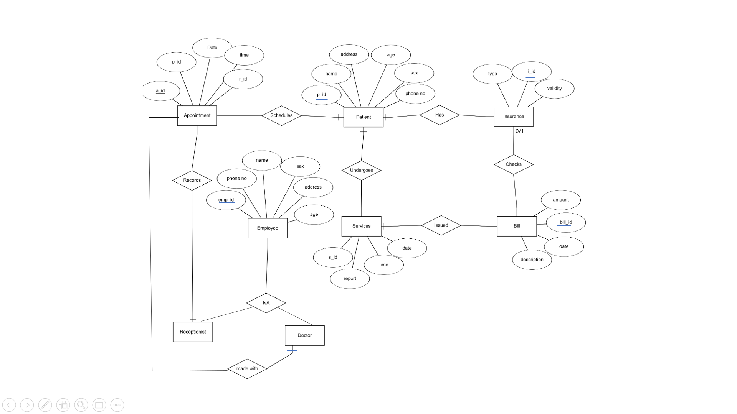

# **DATA DESIGN**

**MAPPING CARDINALITY AND PATISPATION CONSTRAINTS**

A person can take an appointment with single appointment_id. Therefore one to one mapping cardinality between appointment and patient.

Also every patient has one insurance id with which he can pay the bills and acquire the services of the hospital and we can clearly say that it is one to one mapping cardinality between all the tables mentioned latter.

A employee can be both a doctor or receptionist so we can consider it as one to many cardinality mapping.

**DDL COMMANDS**

TABLE CREATED IN SQL:

create table **appointment**(

a_id number,

p_id number,

day date,

r_id number,

primary key(a_id));

create table **patient**(

pa_id number

name varchar(20) NOT NULL,

address varchar(100),

age number NOT NULL,

sex varchar(10),

phone_no number,

primary key(pa_id),

foreign key(pa_id) references appointement(a_id));

create table **insurance**(

type varchar2(10),

i_id number,

validity date));

create table **bill**(

amount number,

bill_id number,

day date,

description varchar(50));

create table **services**(

s_id number,

report varchar(100),

day date,

primary key(s_id));

create table **employee**(

emp_id number,

phone_no number,

name varchar2(20) NOT NULL,

sex varchar(4),

address varchar(100),

age number,

primary key(emp_id));

create table **doctor**(

doc_id number,

specialisation varchar2(50),

primary key(doc_id),

foreign key(doc_id) references employee(emp_id));

create table **receptionist**(

recep_id number,

name varchar2(10),

primary key(recep_id),

foreign key(recep_id) references employee(emp_id));

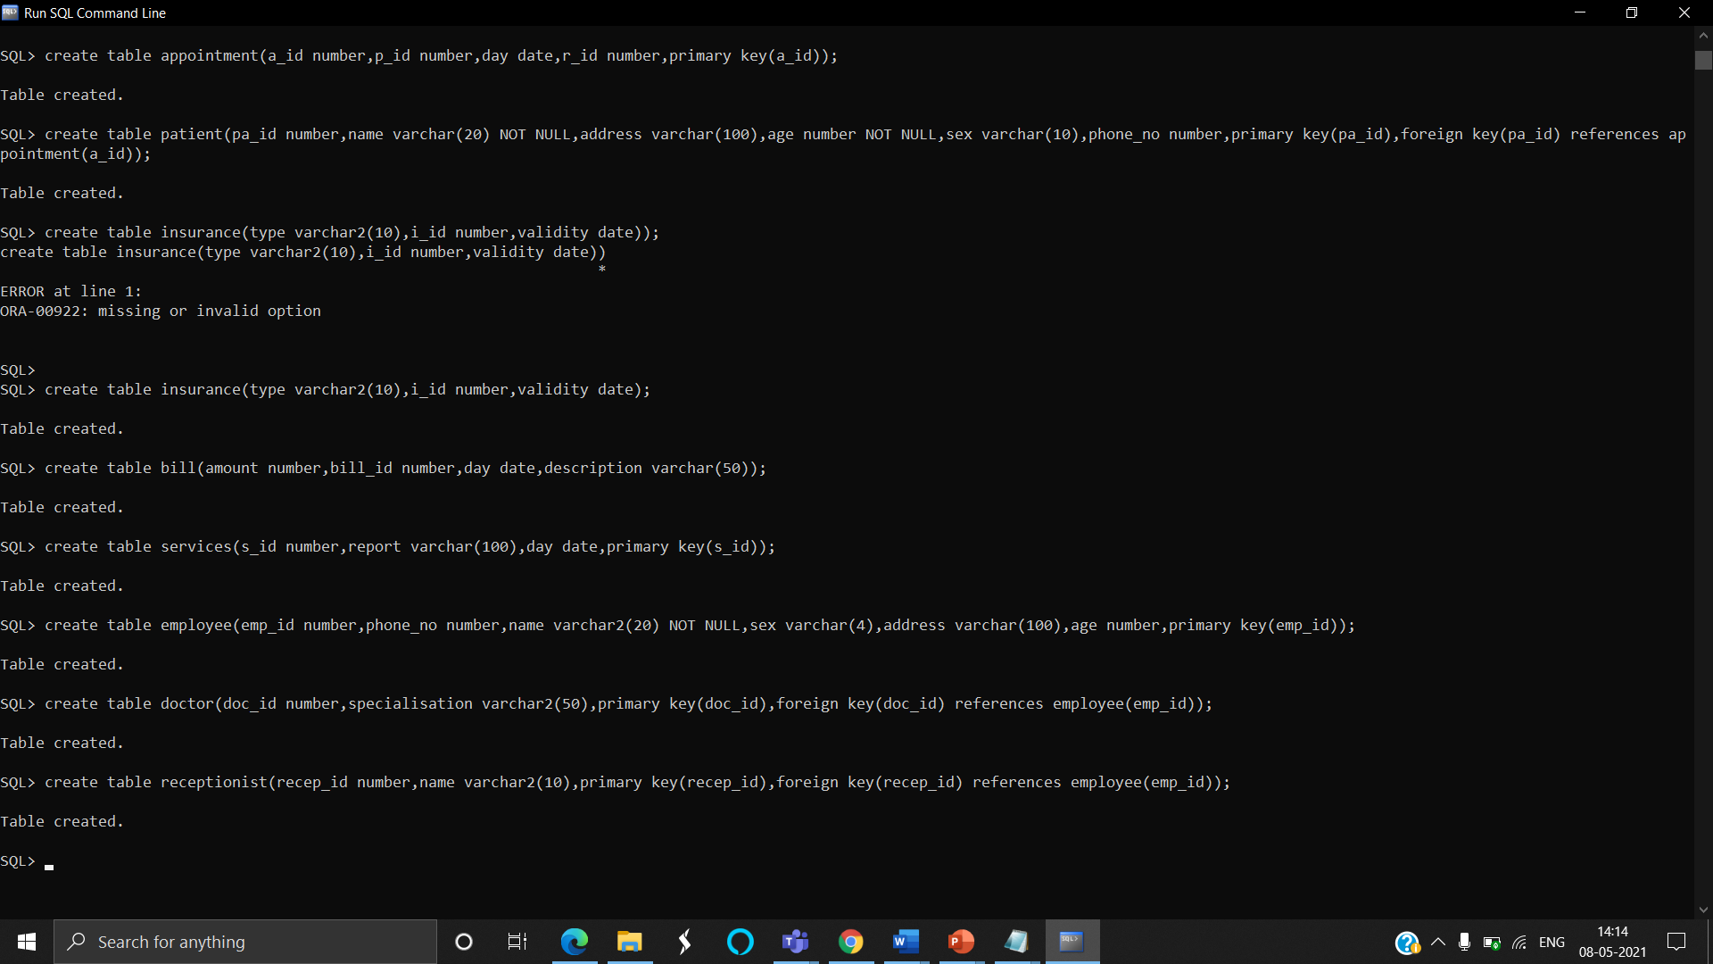

Description of tables:

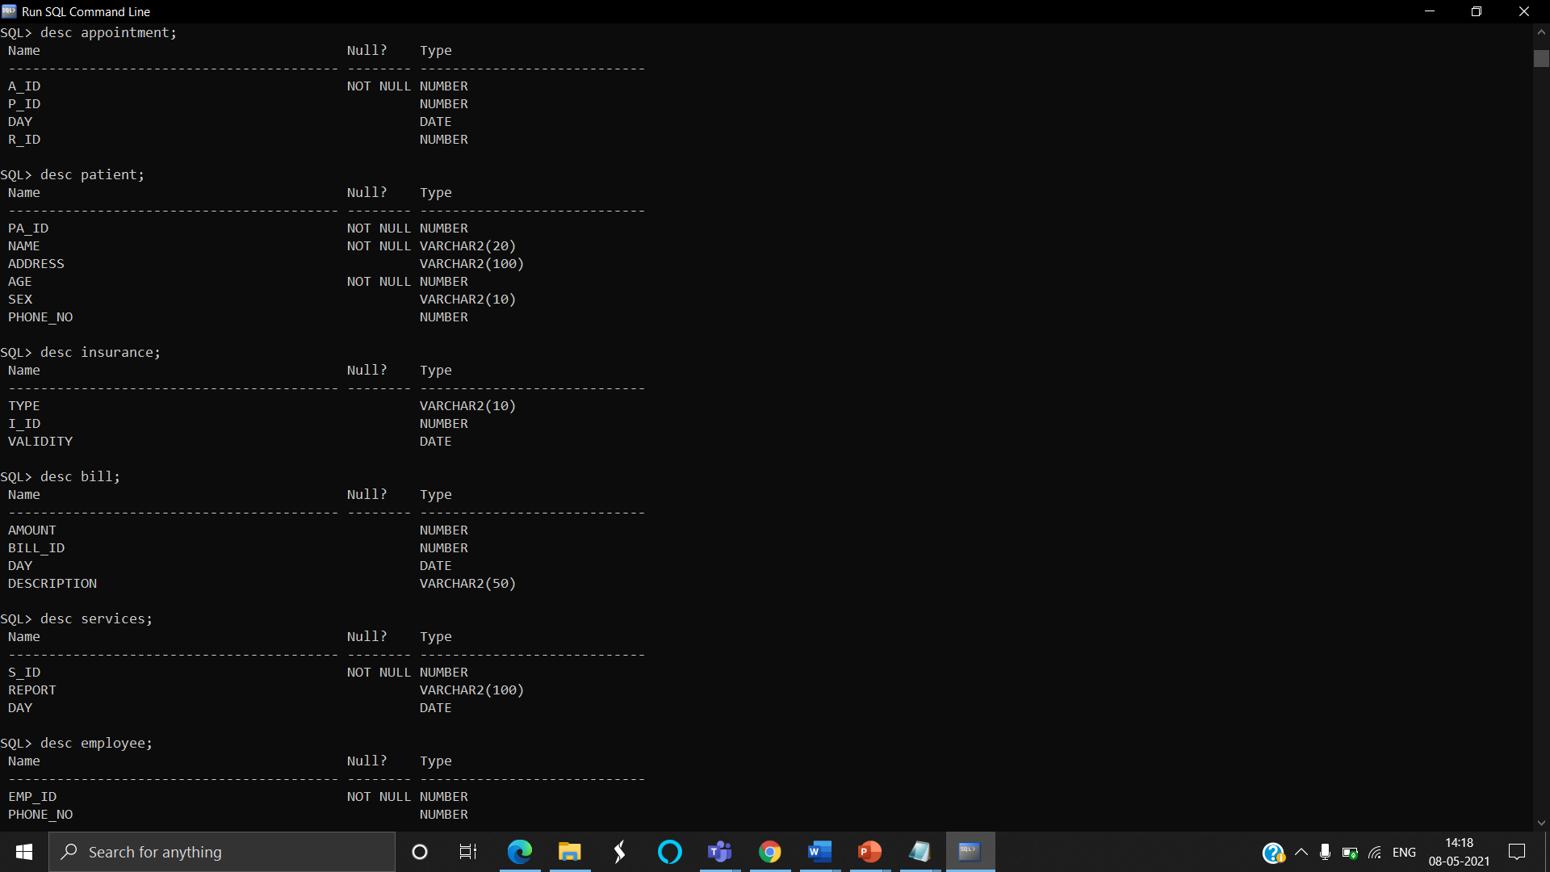

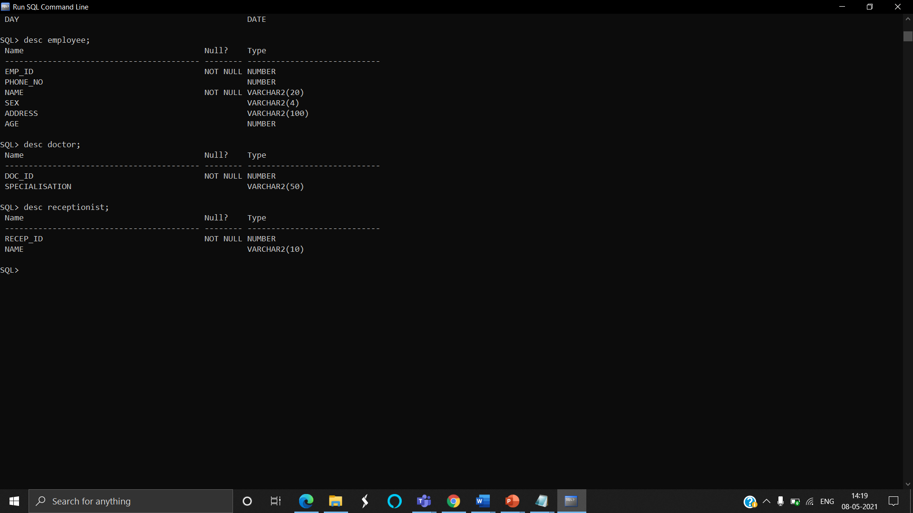

***IMPLEMENTATION:***

**PROGRAM:**

**USER INTERFACE:**

package EMed;

import java.awt.Color;

import java.awt.FlowLayout;

import java.awt.Font;

import java.awt.GridLayout;

import java.awt.Label;

import java.awt.event.WindowAdapter;

import java.awt.event.WindowEvent;

import javax.swing.JFrame;

import javax.swing.JLabel;

import javax.swing.JMenu;

import javax.swing.JMenuBar;

import javax.swing.JMenuItem;

import javax.swing.JOptionPane;

import javax.swing.JPanel;

public class EMedUI extends JFrame{

/**

*

*/

private static final long serialVersionUID = 1L;

private JMenuBar mnu;

private JMenu mnulogin;

private JMenu mnulog_user;

//private JMenu mnudoc;

private JMenu mnumed;

private JMenu mnuuser_med;

private JMenu mnuorder_Det;

private JMenu mnuuser_orderDet;

private JMenu mnudoc;

private JMenu mnurecep;

private JMenuItem insert1,update1,delete1,view1;

private JMenuItem insert2,update2,delete2,view2;

private JMenuItem insert3,update3,delete3,view3;//doc

private JMenuItem insert4,update4,delete4,view4;

private JMenuItem insert5,update5,delete5,view5;

private JMenuItem insert6,update6,delete6,view6;

private JMenuItem insert7,update7,delete7,view7;

private JMenuItem insert8,update8,delete8,view8;//recep

private JLabel labelName;

private static JPanel p0,p1;

void initialize() {

mnu=new JMenuBar();

mnulogin= new JMenu("Appointment");

mnulog_user= new JMenu("Patient");

//mnuuser= new JMenu("User");

mnumed= new JMenu("Insurance");

mnuuser_med= new JMenu("Bill");

mnuorder_Det= new JMenu("Services");

mnuuser_orderDet= new JMenu("Employees");

mnudoc= new JMenu("Doctors");

mnurecep= new JMenu("Receptionists");

labelName=new JLabel("MEDICARE");

p1=new JPanel();

p0=new JPanel();

insert1=new JMenuItem("Insert");

update1=new JMenuItem("Update");

delete1=new JMenuItem("Delete");

view1=new JMenuItem("View");

insert2=new JMenuItem("Insert");

update2=new JMenuItem("Update");

delete2=new JMenuItem("Delete");

view2=new JMenuItem("View");

insert3=new JMenuItem("Insert");

update3=new JMenuItem("Update");

delete3=new JMenuItem("Delete");

view3=new JMenuItem("View");

insert4=new JMenuItem("Insert");

update4=new JMenuItem("Update");

delete4=new JMenuItem("Delete");

view4=new JMenuItem("View");

insert5=new JMenuItem("Insert");

update5=new JMenuItem("Update");

delete5=new JMenuItem("Delete");

view5=new JMenuItem("View");

insert6=new JMenuItem("Insert");

update6=new JMenuItem("Update");

delete6=new JMenuItem("Delete");

view6=new JMenuItem("View");

insert7=new JMenuItem("Insert");

update7=new JMenuItem("Update");

delete7=new JMenuItem("Delete");

view7=new JMenuItem("View");

insert8=new JMenuItem("Insert");

update8=new JMenuItem("Update");

delete8=new JMenuItem("Delete");

view8=new JMenuItem("View");

}

void addComponentsToFrame() {

mnulogin.add(insert1);

mnulogin.add(delete1);

mnulogin.add(update1);

mnulogin.add(view1);

mnulog_user.add(insert2);

mnulog_user.add(delete2);

mnulog_user.add(update2);

mnulog_user.add(view2);

mnudoc.add(insert3);

mnudoc.add(delete3);

mnudoc.add(update3);

mnudoc.add(view3);

mnumed.add(insert4);

mnumed.add(delete4);

mnumed.add(update4);

mnumed.add(view4);

mnuuser_med.add(insert5);

mnuuser_med.add(delete5);

mnuuser_med.add(update5);

mnuuser_med.add(view5);

mnuorder_Det.add(insert6);

mnuorder_Det.add(delete6);

mnuorder_Det.add(update6);

mnuorder_Det.add(view6);

mnuuser_orderDet.add(insert7);

mnuuser_orderDet.add(delete7);

mnuuser_orderDet.add(update7);

mnuuser_orderDet.add(view7);

mnurecep.add(insert8);

mnurecep.add(delete8);

mnurecep.add(update8);

mnurecep.add(view8);

mnu.add(mnulogin);

mnu.add(mnulog_user);

mnu.add(mnumed);

mnu.add(mnuuser_med);

mnu.add(mnuorder_Det);

mnu.add(mnuuser_orderDet);

mnu.add(mnudoc);

mnu.add(mnurecep);

setJMenuBar(mnu);

p1.add(labelName);p1.setAlignmentY(CENTER_ALIGNMENT);

p1.setBounds(500,500,800,100);

p0.add(p1);

p0.setBackground(Color.BLACK);

add(p0);

}

void closeWindow(){

try {

int a=JOptionPane.showConfirmDialog(this,"Are you sure want to Quit MEDICARE");

if(a==JOptionPane.YES_OPTION){

JOptionPane.showMessageDialog(this,

"Thank you!\nExiting MEDICARE","Quit",

JOptionPane.WARNING_MESSAGE);

System.exit(0);

}

else if (a== JOptionPane.NO_OPTION) {

setDefaultCloseOperation(JFrame.DO_NOTHING_ON_CLOSE);

}

else if (a== JOptionPane.CANCEL_OPTION) {

setDefaultCloseOperation(JFrame.DO_NOTHING_ON_CLOSE);

}

}

catch(Exception e) {

System.out.println(e);

}

}

void register() {

login log=new login(p0,EMedUI.this,insert1,delete1,update1,view1);

log.buildGUI();

/*doctor user=new User_account(p0,EMedUI.this,insert3,delete3,update3,view3);

dcotor.buildGUI();*/

login_user log_user=new login_user(p0,EMedUI.this,insert2,delete2,update2,view2);

log_user.buildGUI();

Medicine med=new Medicine(p0,EMedUI.this,insert4,delete4,update4,view4);

med.buildGUI();

UserMedicine umed=new UserMedicine(p0,EMedUI.this,insert5,delete5,update5,view5);

umed.buildGUI();

orderDetails orders=new orderDetails(p0,EMedUI.this,insert6,delete6,update6,view6);

orders.buildGUI();

UserOrderDetails u_orders=new UserOrderDetails(p0,EMedUI.this,insert7,delete7,update7,view7);

u_orders.buildGUI();

Doctor doc=new Doctor(p0,EMedUI.this,insert3,delete3,update3,view3);

doc.buildGUI();

Recep rec=new Recep(p0,EMedUI.this,insert8,delete8,update8,view8);

rec.buildGUI();

addWindowListener(new WindowAdapter(){

public void windowClosing(WindowEvent we)

{

closeWindow();

}

});

}

public EMedUI() {

initialize();

addComponentsToFrame();

register();

pack();

// setBackground(Color.RED);

setTitle("MEDICARE");

setSize(800,800);

setVisible(true);

}

}

APPOINTMENT TABLE

package EMed;

import java.awt.BorderLayout;

import java.awt.Color;

import java.awt.FlowLayout;

import java.awt.Font;

import java.awt.GridLayout;

import java.awt.Label;

import java.awt.List;

import java.awt.event.ActionEvent;

import java.awt.event.ActionListener;

import java.awt.event.ItemEvent;

import java.awt.event.ItemListener;

import java.sql.*;

import javax.swing.JButton;

import javax.swing.JFrame;

import javax.swing.JLabel;

import javax.swing.JMenuItem;

import javax.swing.JOptionPane;

import javax.swing.JPanel;

import javax.swing.JScrollPane;

import javax.swing.JTable;

import javax.swing.JTextField;

import javax.swing.table.DefaultTableModel;

public class Appointment{

/**

*

*/

private static final long serialVersionUID = 1L;

private JButton insertButton,deleteButton,updateButton,viewButton;

private JPanel p1,p2,p3,p;

private JLabel lbla_id,lblp_id,lblday,lblr_id;

private JTextField txta_id,txtp_id,txtday,txtr_id;

private List MIDList;

Connection con;ResultSet rs;

Statement statement;

private JFrame frame;

private JMenuItem insert,delete,update,view;

public Appointment(JPanel p,JFrame frame,JMenuItem insert,JMenuItem delete,JMenuItem update,JMenuItem view)

{

try

{

Class.forName("oracle.jdbc.driver.OracleDriver");

}

catch (Exception e)

{

System.err.println("Unable to find and load driver");

System.exit(1);

}

connectToDB();

this.frame=frame;

this.insert=insert;

this.delete=delete;

this.update=update;

this.view=view;

lbla_id=new JLabel("Appointement ID");

lblp_id=new JLabel("Patient ID");

lblday=new JLabel("Day");

lblr_id=new JLabel("Record ID");

txta_id=new JTextField(15);

txtp_id=new JTextField(15);

txtday=new JTextField(8);

txtr_id=new JTextField(15);

this.p=p;

}

public void connectToDB()

{

try {

Connection con=DriverManager.getConnection(

"jdbc:oracle:thin:@localhost:1521:xe","PRO","charvee");

statement=con.createStatement();

statement.executeUpdate("commit");

}

catch (SQLException connectException)

{

System.out.println(connectException.getMessage());

System.out.println(connectException.getSQLState());

System.out.println(connectException.getErrorCode());

System.exit(1);

}

}

private void displaySQLErrors(SQLException e)

{

JOptionPane.showMessageDialog(p,"\nSQLException: " + e.getMessage() + "\n"+"SQLState: " + e.getSQLState() + "\n"+"VendorError: " + e.getErrorCode() + "\n");

}

public void loadAppointIDs() {

try {

MIDList.removeAll();

rs=statement.executeQuery("select a_id from Appointment");

while(rs.next()) {

MIDList.add(rs.getString("a_id"));

}

}

catch(SQLException e) {

displaySQLErrors(e);

}

}

public void buildGUI() {

insert.addActionListener(new ActionListener() {

@Override

public void actionPerformed(ActionEvent arg0) {

// TODO Auto-generated method stub

insertButton=new JButton("submit");

txta_id.setText(null);

txtp_id.setText(null);

txtday.setText(null);

txtr_id.setText(null);

p.removeAll();

frame.invalidate();

frame.validate();

frame.repaint();

p1=new JPanel();

p1.setLayout(new GridLayout(4,2));

p1.add(lbla_id);

p1.add(txta_id);

p1.add(lblp_id);

p1.add(txtp_id);

p1.add(lblday);

p1.add(txtday);

p1.add(lblr_id);

p1.add(txtr_id);

p3=new JPanel(new FlowLayout());

p3.add(insertButton);

//p1.add(txtf1);

p3.setBackground(Color.yellow);

p1.setBounds(115,80,300,250);p3.setBounds(200,350,75,35);

p1.setBackground(Color.pink) ;

p2 = new JPanel(new FlowLayout());

MIDList=new List(10);

loadAppointIDs();

p2.add(MIDList);p2.setBackground(Color.yellow) ;

p2.setBounds(450,150,350,180);

p. add(p1);p.add(p3);

p. add(p2);

p.setLayout(new BorderLayout());

frame.add(p);

frame.setSize(800,800);

frame.validate();

insertButton.addActionListener(new ActionListener() {

@Override

public void actionPerformed(ActionEvent e) {

// TODO Auto-generated method stub

try {

String query="INSERT INTO Appointment VALUES("+txta_id.getText()+","+txtp_id.getText()+",'"+txtday.getText()+"',"+txtr_id.getText()+")";

int i=statement.executeUpdate(query);

JOptionPane.showMessageDialog(p,"\ninserted "+i+" rows succesfully");loadAppointIDs();

}

catch(SQLException insertException){

displaySQLErrors(insertException);

}

}

});

}

});

delete.addActionListener(new ActionListener() {

@Override

public void actionPerformed(ActionEvent arg0) {

// TODO Auto-generated method stub

deleteButton=new JButton("delete");

txta_id.setText(null);

txtp_id.setText(null);

txtday.setText(null);

txtr_id.setText(null);

p.removeAll();

frame.invalidate();

frame.validate();

frame.repaint();

p1=new JPanel();

p1.setLayout(new GridLayout(4,2));

p1.add(lbla_id);

p1.add(txta_id);

p1.add(lblp_id);

p1.add(txtp_id);

p1.add(lblday);

p1.add(txtday);

p1.add(lblr_id);

p1.add(txtr_id);

p3=new JPanel(new FlowLayout());

p3.add(deleteButton);

//p1.add(txtf1);

p3.setBackground(Color.yellow);

p1.setBounds(115,80,300,250);p3.setBounds(200,350,75,35);

p1.setBackground(Color.pink) ;

// p1.setBounds(100,100,500,300);

p2 = new JPanel(new FlowLayout());

MIDList=new List(10);

loadAppointIDs();

p2.add(MIDList);p2.setBackground(Color.yellow) ;

p2.setBounds(450,150,350,180);

p. add(p1);p.add(p3);

p. add(p2);

MIDList.addItemListener(new ItemListener()

{

public void itemStateChanged(ItemEvent e)

{

try

{

rs=statement.executeQuery("select * from Appointment");

while (rs.next())

{

if (rs.getString("a_id").equals(MIDList.getSelectedItem()))

break;

}

if (!rs.isAfterLast())

{

txta_id.setText(rs.getString("a_id"));

txtp_id.setText(rs.getString("p_id"));

txtday.setText(rs.getString("day"));

txtr_id.setText(rs.getString("r_id"));

}

}

catch (SQLException selectException)

{

displaySQLErrors(selectException);

}

}

});

p.setLayout(new BorderLayout());

frame.add(p);

frame.setSize(800,800);

frame.validate();

deleteButton.addActionListener(new ActionListener() {

@Override

public void actionPerformed(ActionEvent e) {

// TODO Auto-generated method stub

try {

int a=JOptionPane.showConfirmDialog(p,"Are you sure want to delete:");

if(a==JOptionPane.YES_OPTION){

String query="DELETE FROM Appointment WHERE A_ID="+MIDList.getSelectedItem();

int i=statement.executeUpdate(query);

JOptionPane.showMessageDialog(p,"\nDeleted "+i+" rows succesfully");loadAppointIDs();

}

}

catch(SQLException deleteException){

displaySQLErrors(deleteException);

}

}

});

}

});

update.addActionListener(new ActionListener() {

@Override

public void actionPerformed(ActionEvent arg0) {

// TODO Auto-generated method stub

JButton updateButton = new JButton("modify");

txta_id.setText(null);

txtp_id.setText(null);

txtday.setText(null);

txtr_id.setText(null);

p.removeAll();

frame.invalidate();

frame.validate();

frame.repaint();

p1=new JPanel();

p1.setLayout(new GridLayout(4,2));

p1.add(lbla_id);

p1.add(txta_id);

p1.add(lblp_id);

p1.add(txtp_id);

p1.add(lblday);

p1.add(txtday);

p1.add(lblr_id);

p1.add(txtr_id);

p3=new JPanel(new FlowLayout());

p3.add(updateButton);

//p1.add(txtf1);

p3.setBackground(Color.yellow);

p1.setBounds(115,80,300,250);p3.setBounds(200,350,75,35);

p1.setBackground(Color.pink) ;

p2 = new JPanel(new FlowLayout());

MIDList=new List(10);

loadAppointIDs();

p2.add(MIDList);p2.setBackground(Color.yellow) ;

p2.setBounds(450,150,350,180);

p. add(p1);p.add(p3);

p. add(p2);

MIDList.addItemListener(new ItemListener()

{

public void itemStateChanged(ItemEvent e)

{

try

{

rs=statement.executeQuery("select * from Appointment");

while (rs.next())

{

if (rs.getString("a_id").equals(MIDList.getSelectedItem()))

break;

}

if (!rs.isAfterLast())

{

txta_id.setText(rs.getString("a_id"));

txtp_id.setText(rs.getString("p_id"));

txtday.setText(rs.getString("day"));

txtr_id.setText(rs.getString("r_id"));

}

}

catch (SQLException selectException)

{

displaySQLErrors(selectException);

}

}

});

p.setLayout(new BorderLayout());

frame.add(p);

frame.setSize(800,800);

frame.validate();

updateButton.addActionListener(new ActionListener() {

@Override

public void actionPerformed(ActionEvent e) {

// TODO Auto-generated method stub

try {

int a=JOptionPane.showConfirmDialog(p,"Are you sure want to update:");

if(a==JOptionPane.YES_OPTION){

String query="update Appointment set a_id="+txta_id.getText()+",p_id="+txtp_id.getText()+",day='"+txtday.getText()+"',r_id="+txtr_id.getText()+" WHERE A_ID="+MIDList.getSelectedItem();

//System.out.println(query);

int i=statement.executeUpdate(query);

JOptionPane.showMessageDialog(p,"\nupdated "+i+" rows succesfully");loadAppointIDs();

}

}

catch(SQLException deleteException){

displaySQLErrors(deleteException);

}

}

});

}

});

view.addActionListener(new ActionListener(){

@Override

public void actionPerformed(ActionEvent arg0) {

// TODO Auto-generated method stub

p.removeAll();

frame.invalidate();

frame.validate();

frame.repaint();

Label view1=new Label("Appointment view");

//view1.setAlignment(Label.CENTER);

Font myFont = new Font("Serif",Font.BOLD,50);

view1.setFont((myFont));

viewButton=new JButton("View");

p1=new JPanel();

p2=new JPanel();

p1.add(view1);

p2.add(viewButton);p1.setBackground(Color.yellow) ;p2.setBackground(Color.yellow) ;

p.add(p1);p.add(p2); p.setLayout(new FlowLayout());

frame.add(p);

frame.setSize(800,800);

frame.validate();

viewButton.addActionListener(new ActionListener() {

@Override

public void actionPerformed(ActionEvent e) {

// TODO Auto-generated method stub

JFrame f;

JTable j;

f = new JFrame();

f.setTitle("Appointment details");

DefaultTableModel model = new DefaultTableModel();

j = new JTable(model);

model.addColumn("Apppointment id");

model.addColumn("patient id");

model.addColumn("day");

model.addColumn("record id");

try {

rs=statement.executeQuery("select * from appointment");

while(rs.next()) {

model.addRow(new Object[]{rs.getInt("a_id"), rs.getInt("p_id"),rs.getString("day"),rs.getInt("r_id")});

}

}

catch(SQLException viewException) {

displaySQLErrors(viewException);

}

j.setEnabled(false);

j.setBounds(30, 40, 300, 300);

JScrollPane sp = new JScrollPane(j);

f.add(sp);

f.setSize(800, 400);

f.setVisible(true);

}

});

}

});

}

}

**GITHUB LINK:**

https://github.com/CharveeKrishna/MEDICARE

# FOLDER STRUCTURE

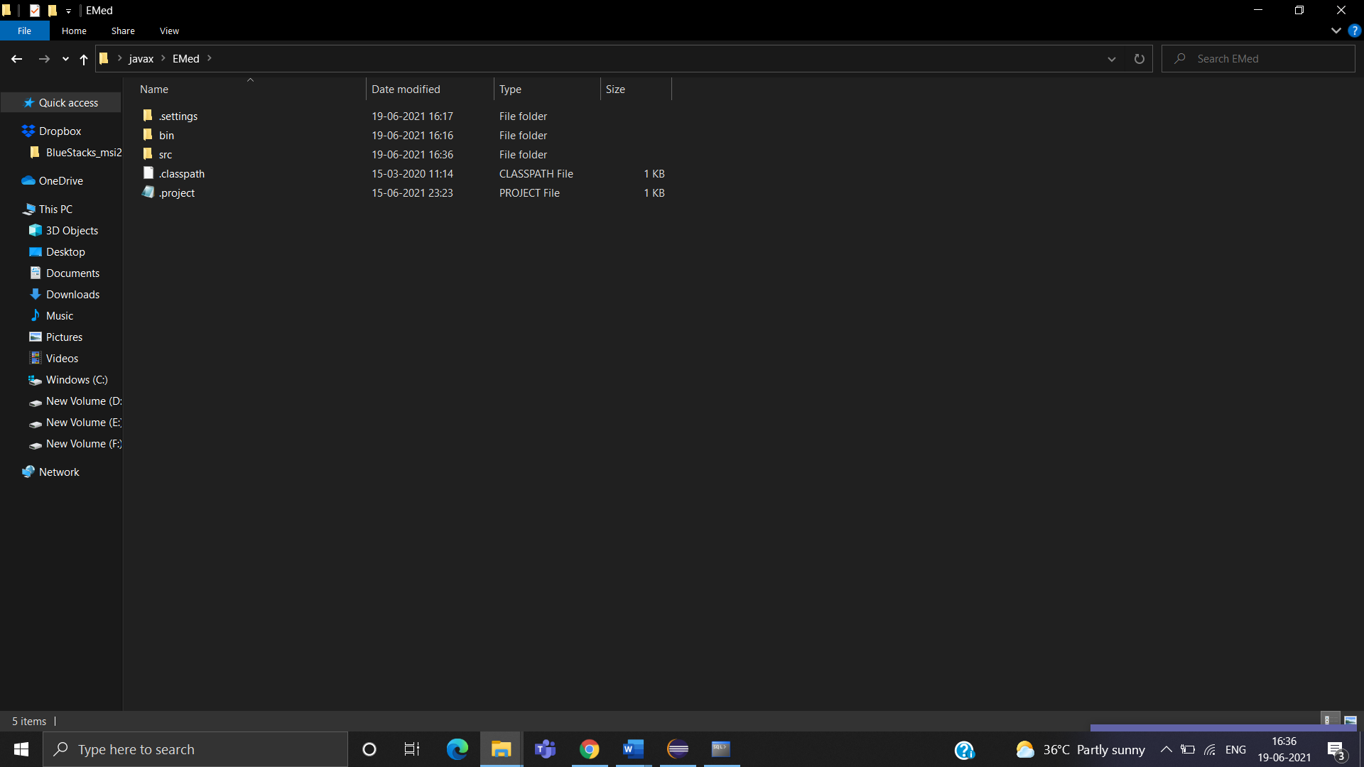

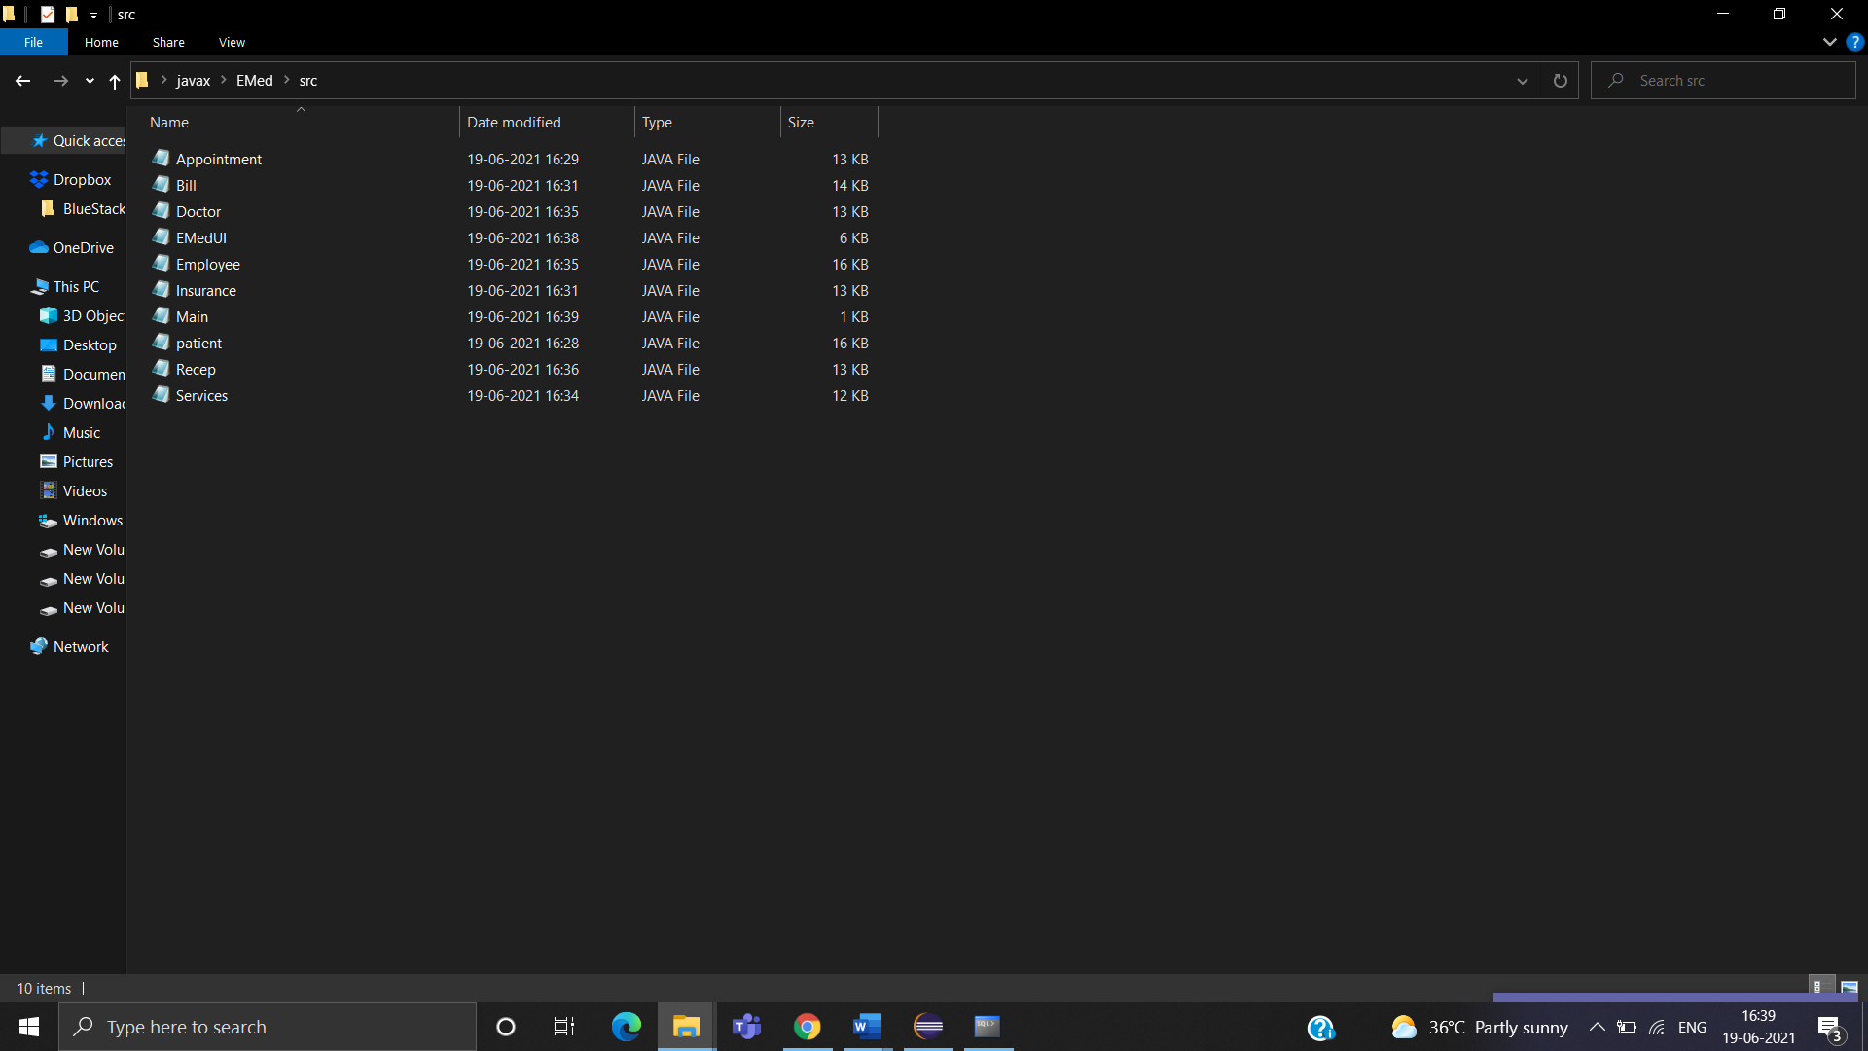

# Testing:

# **OUTPUT SCREENSHOTS:**

**MAIN PAGE:**

It displays the title of the project and it has menu items which are named after the 8 tables. Each menu item provides three options that can be performed on that particular table: Insert, Update and Delete.

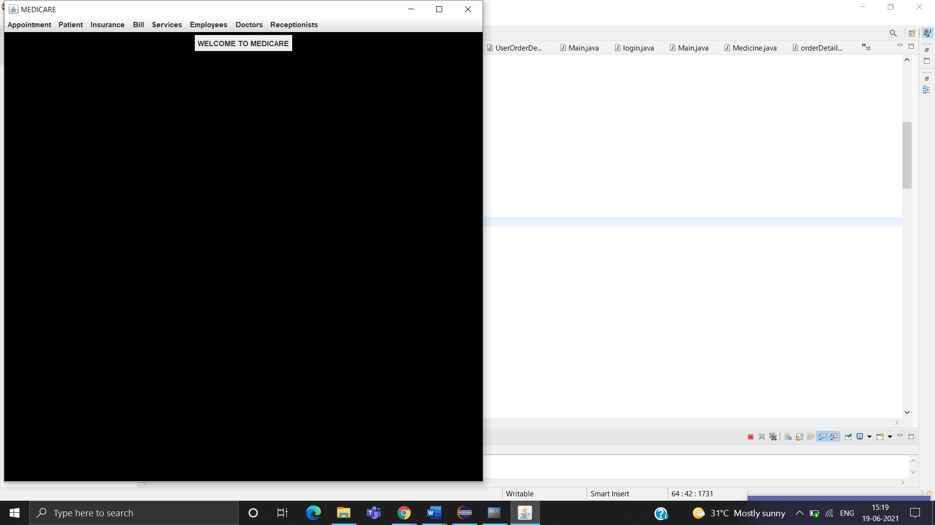

##### **Java GUI Screenshot:**

APPOINTMENT TABLE:

SUBMIT:

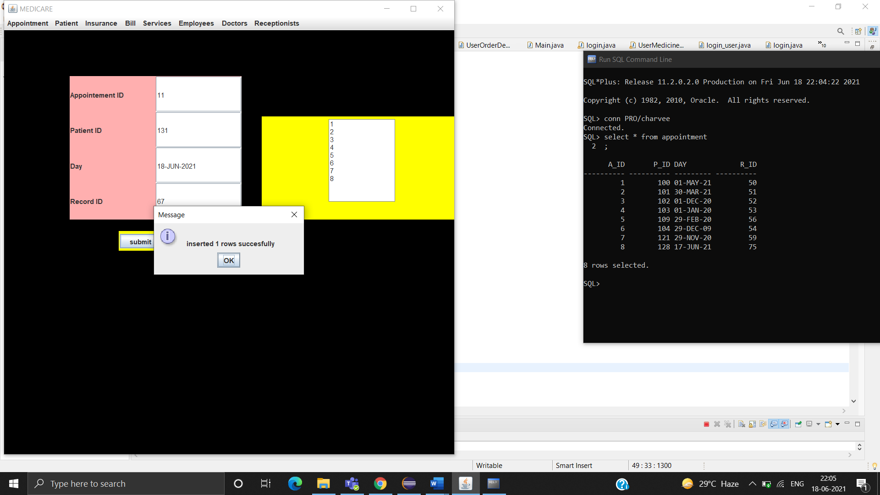

DELETE:

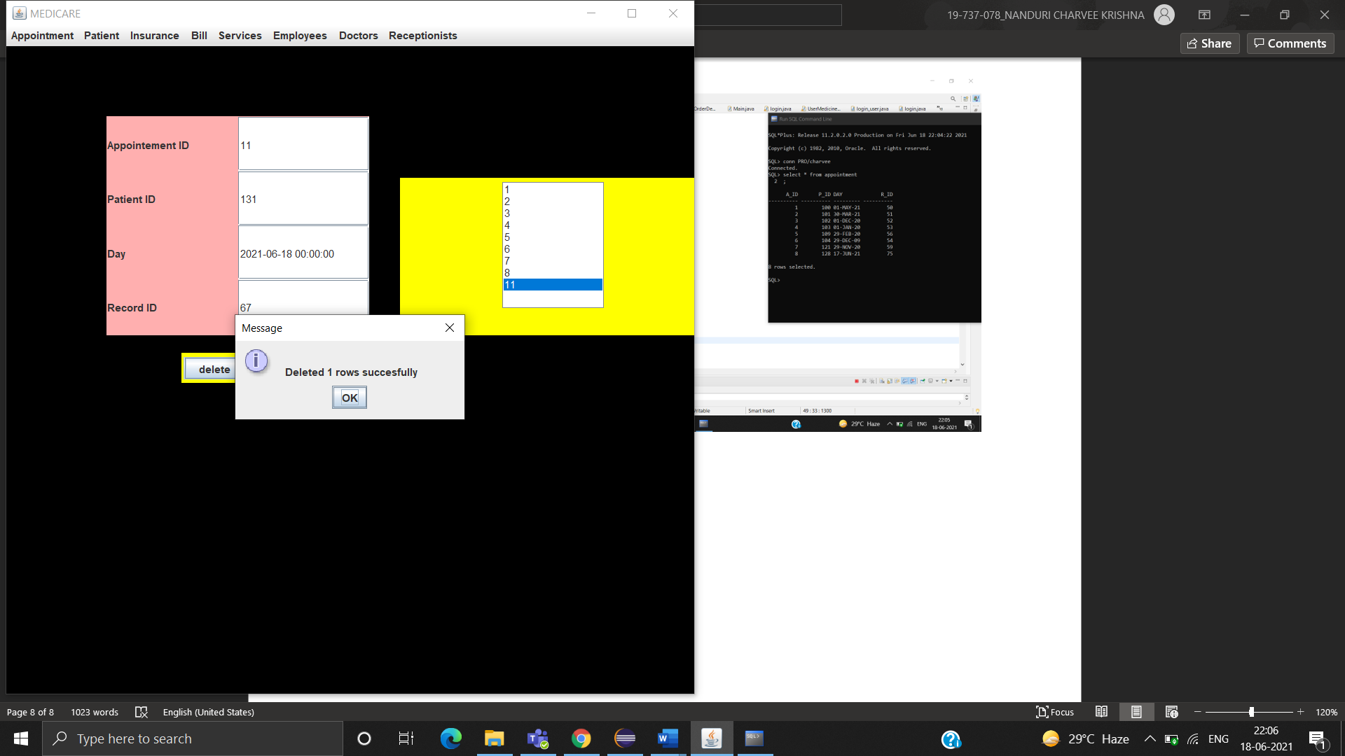

MODIFY:

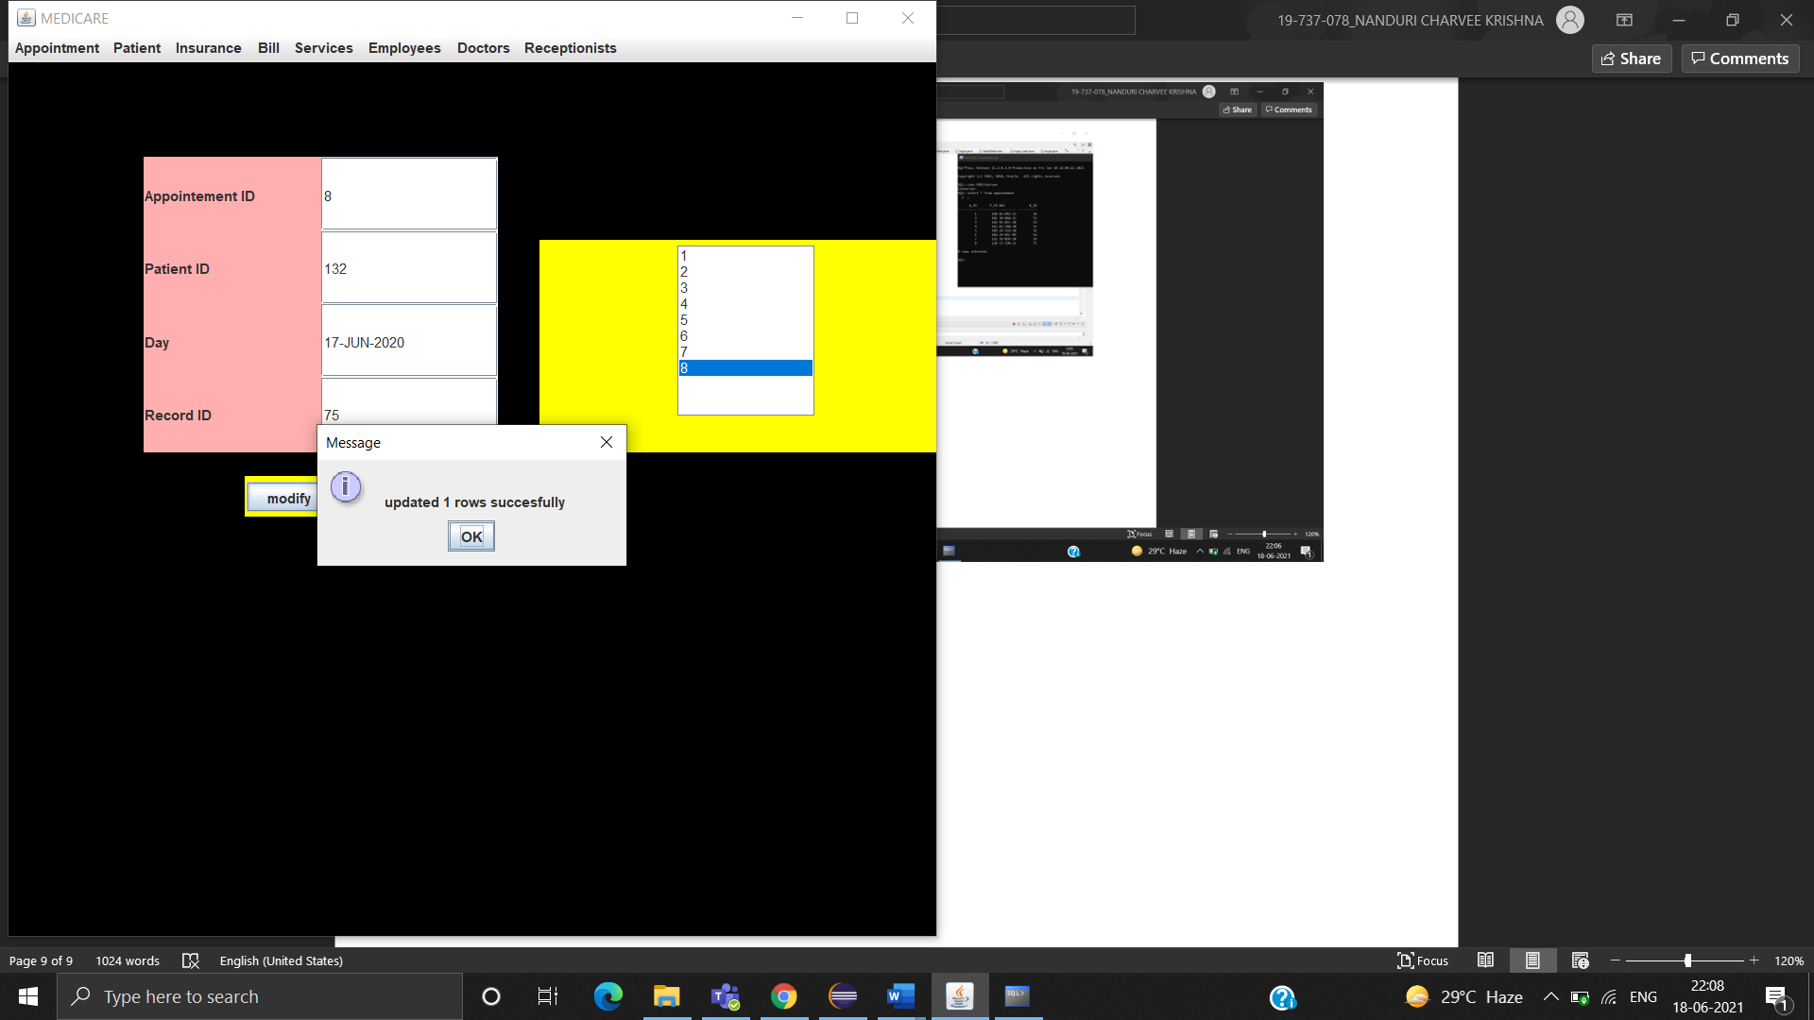

VIEW:

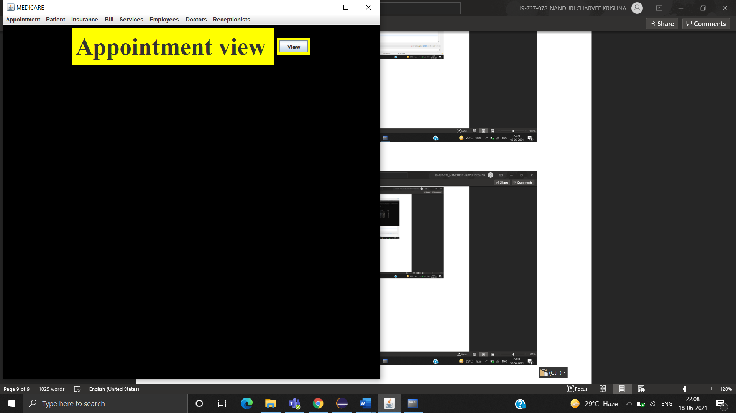

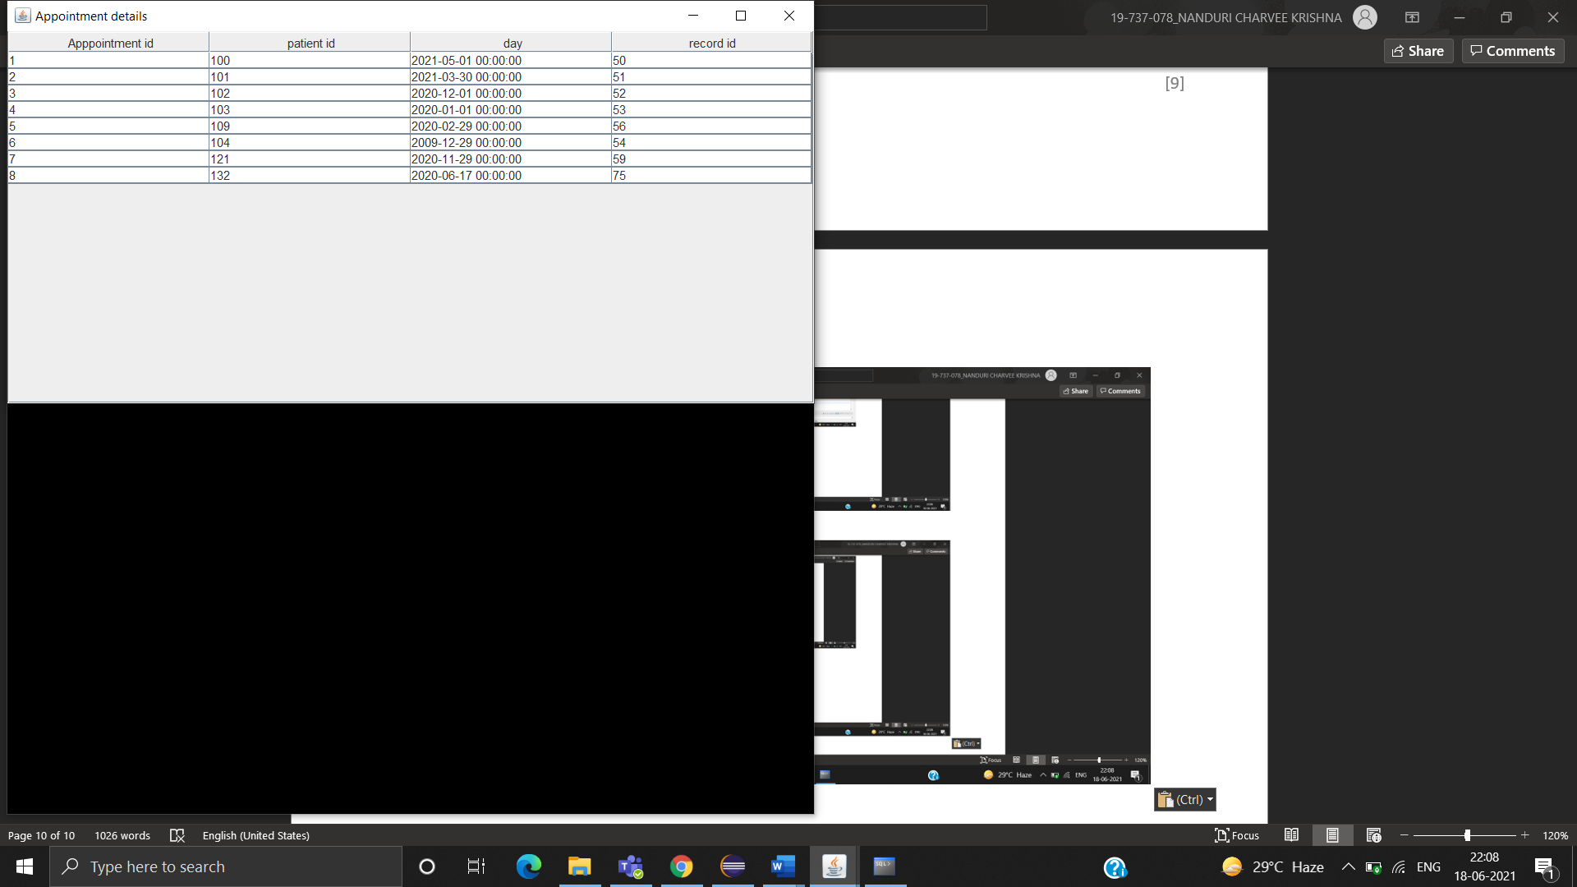

PATIENT TABLE:

SUBMIT

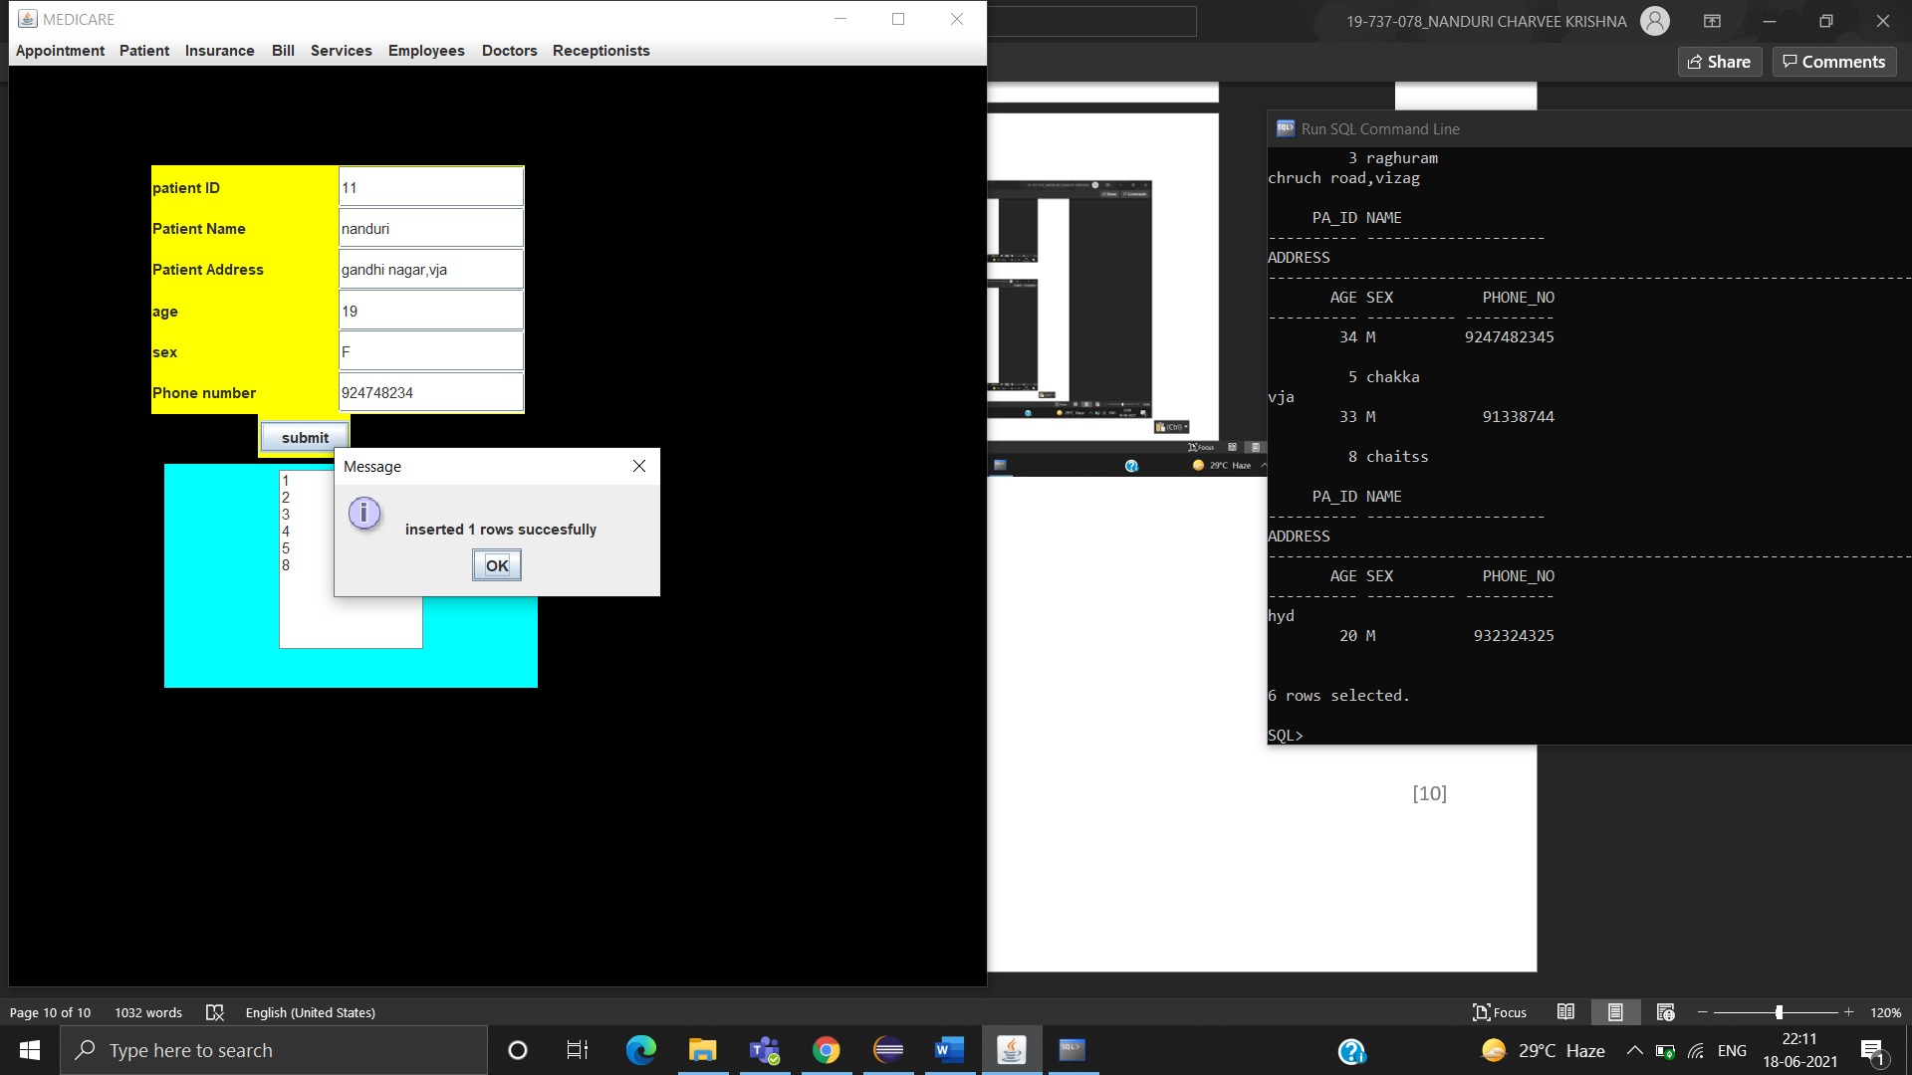

TEST CASE:

Patient table is associated with a relationship with Appointment table, so it cannot be deleted

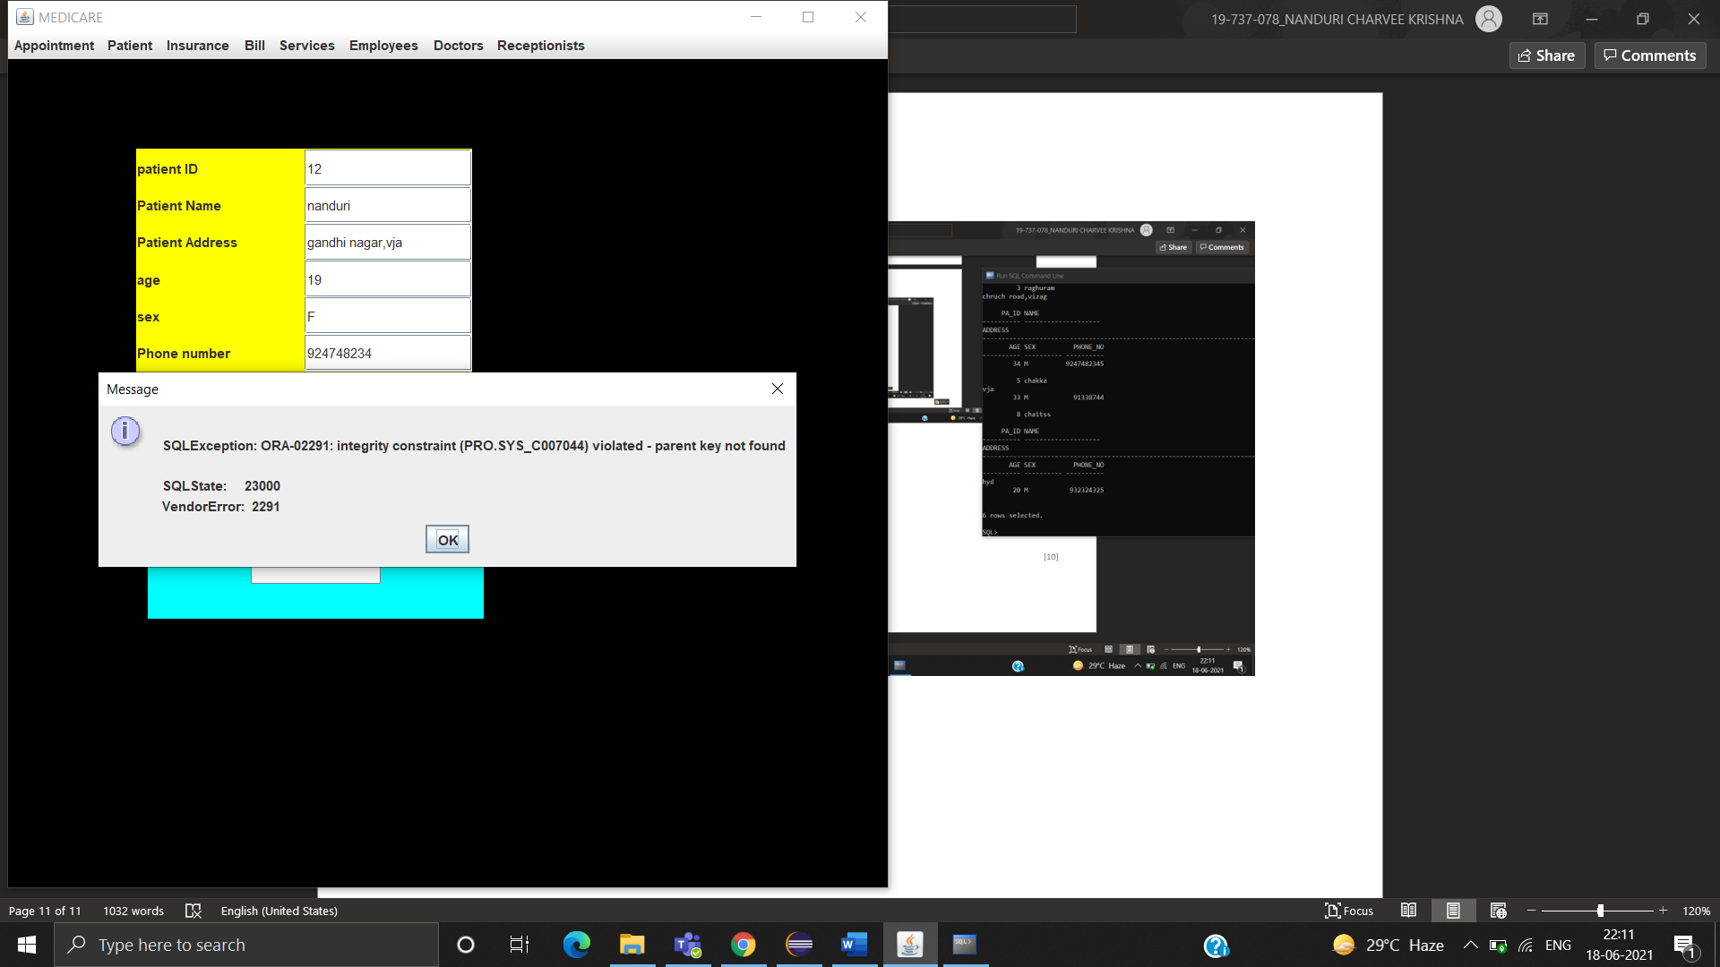

DELETE

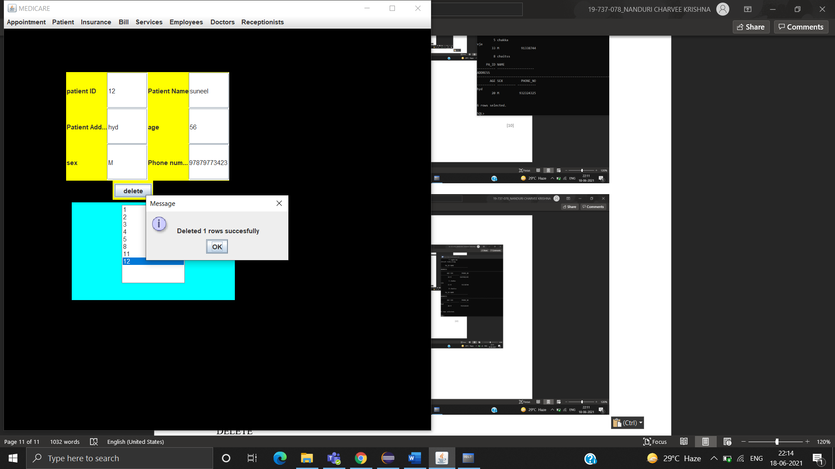

MODIFY

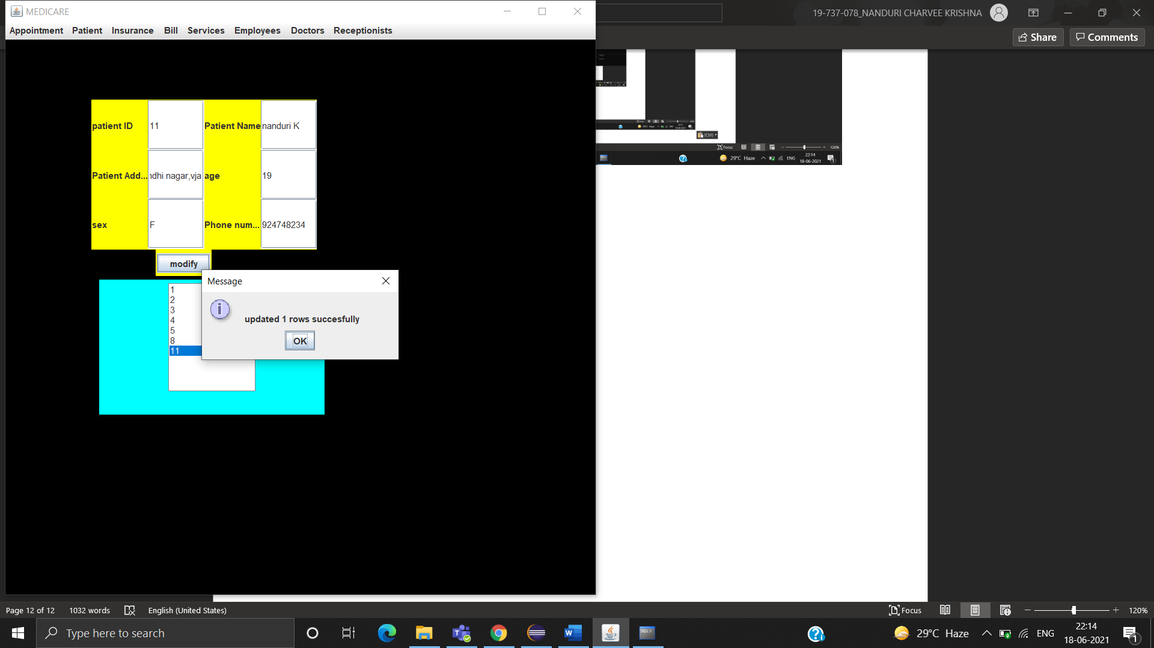

VIEW

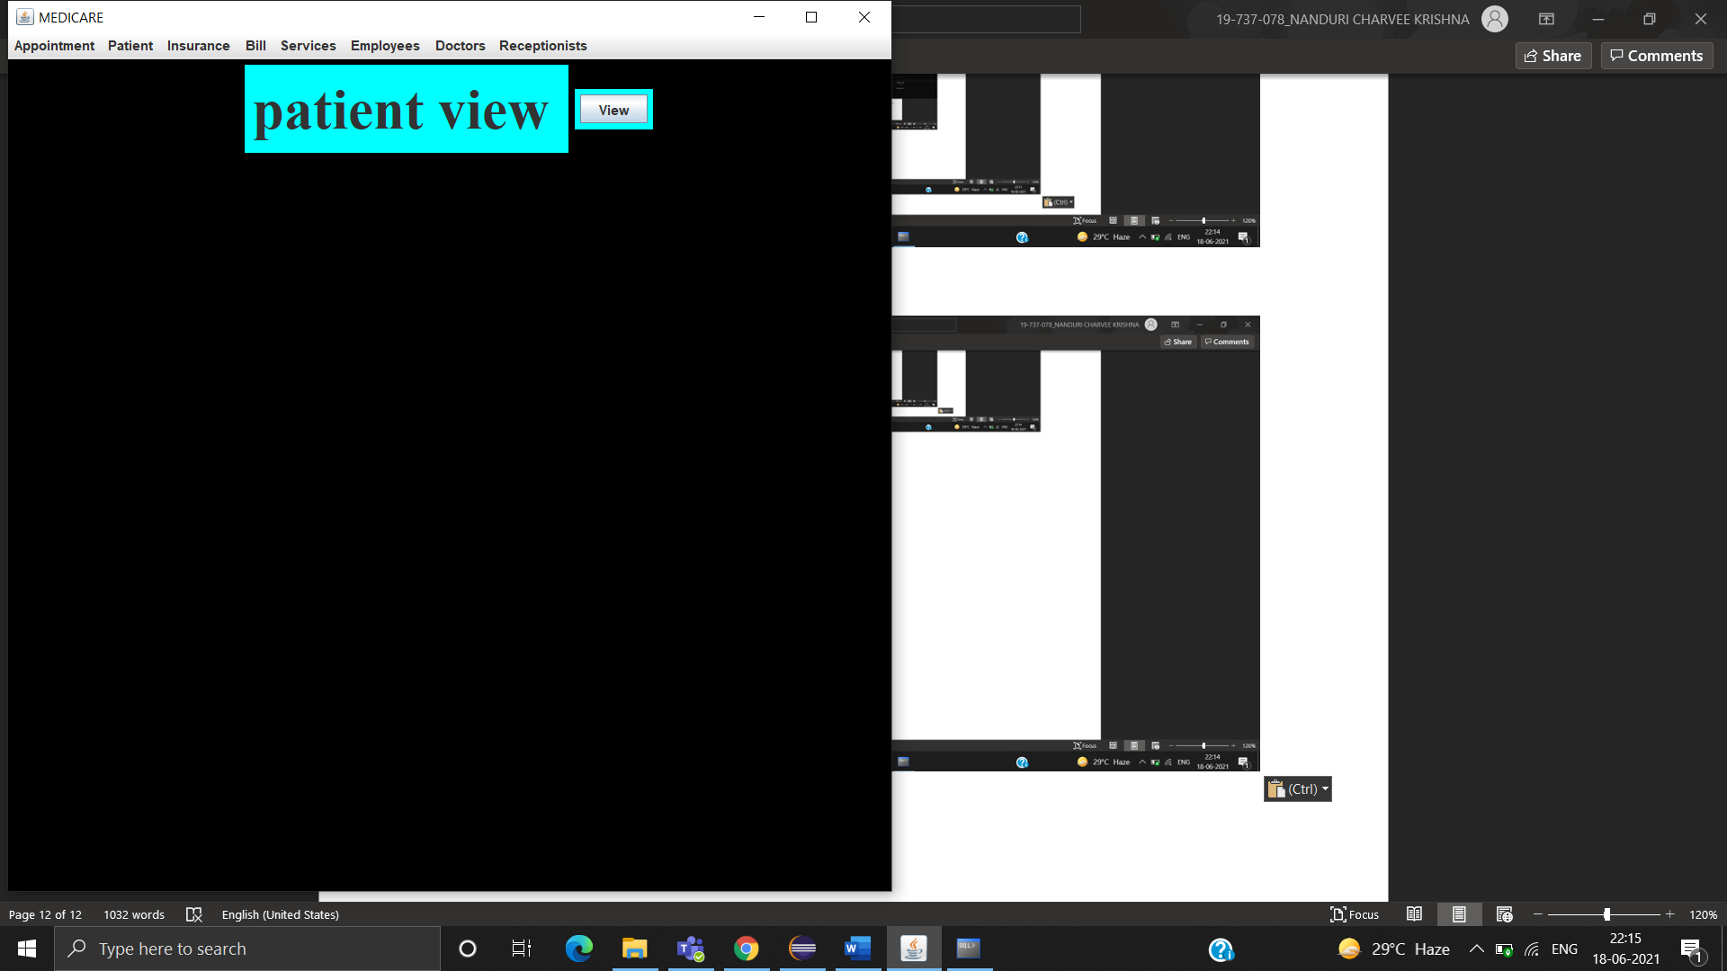

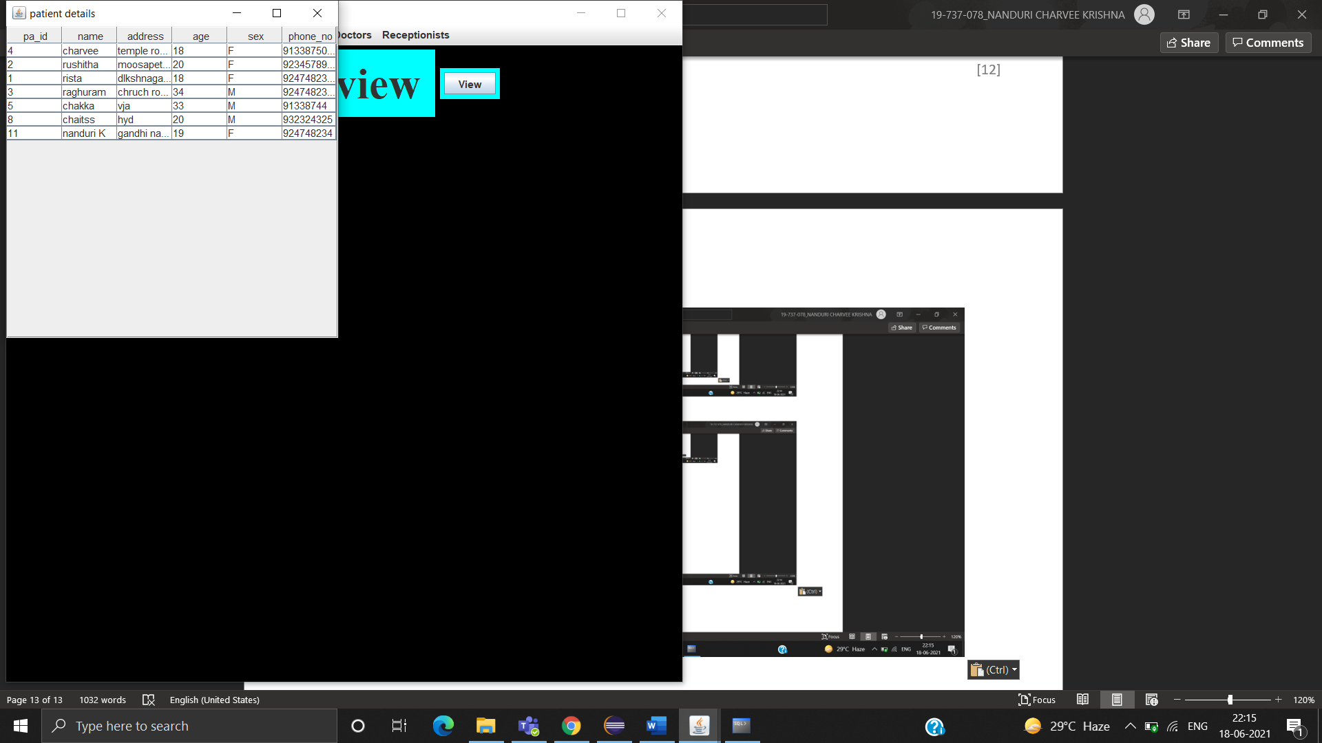

INSURANCE TABLE:

SUBMIT

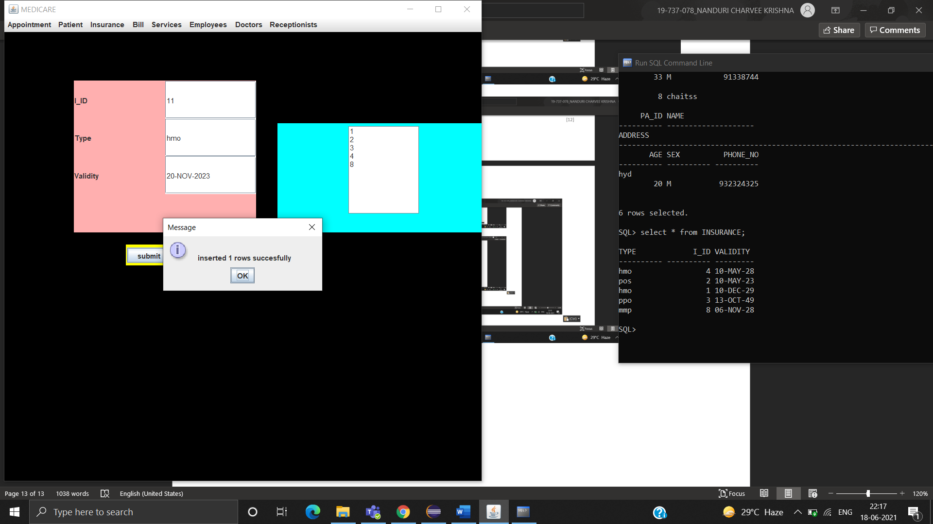

DELETE

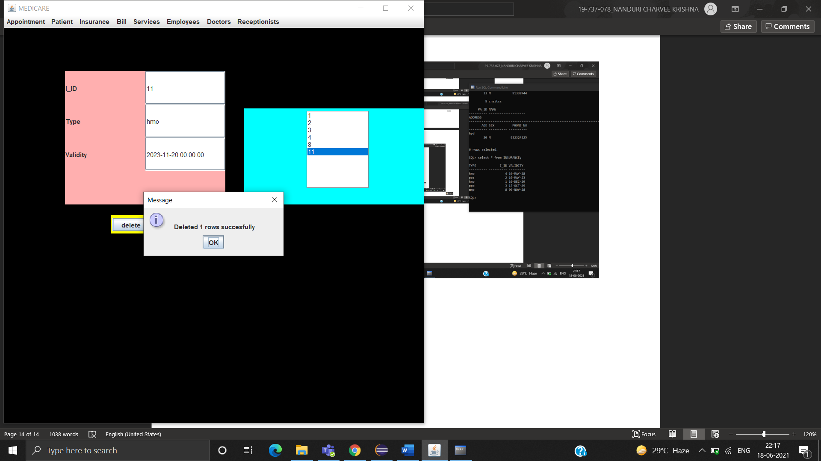

MODIFY

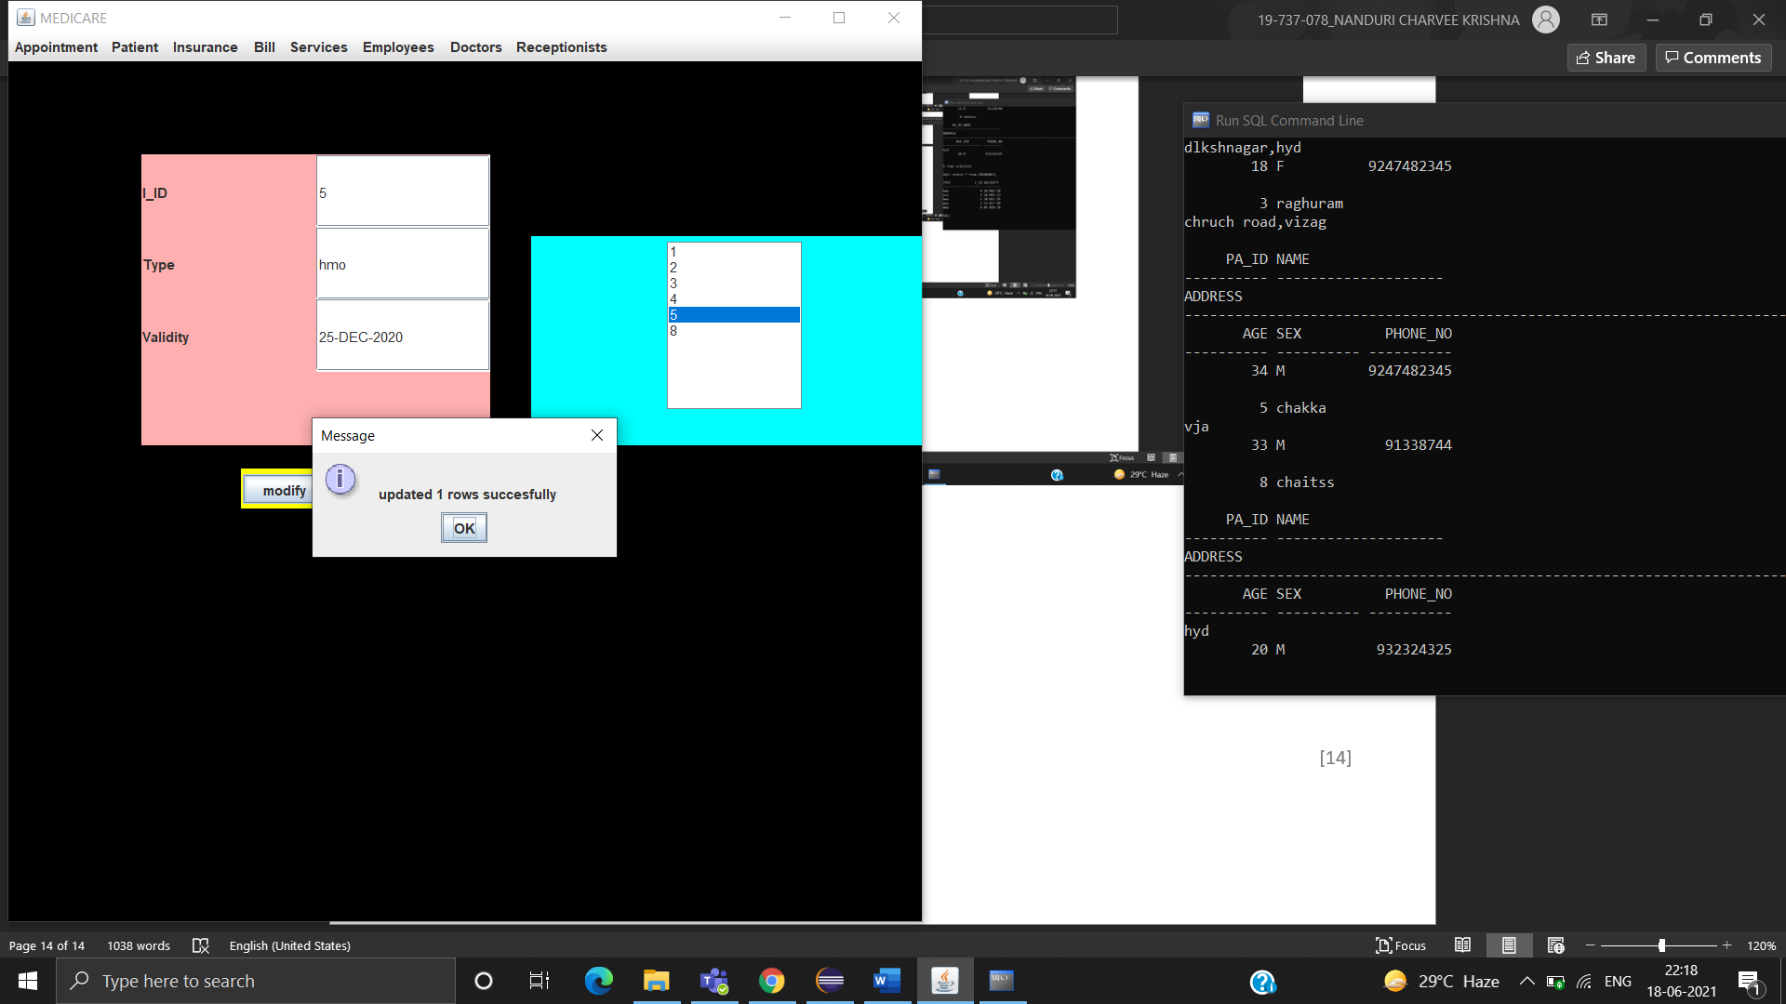

VIEW

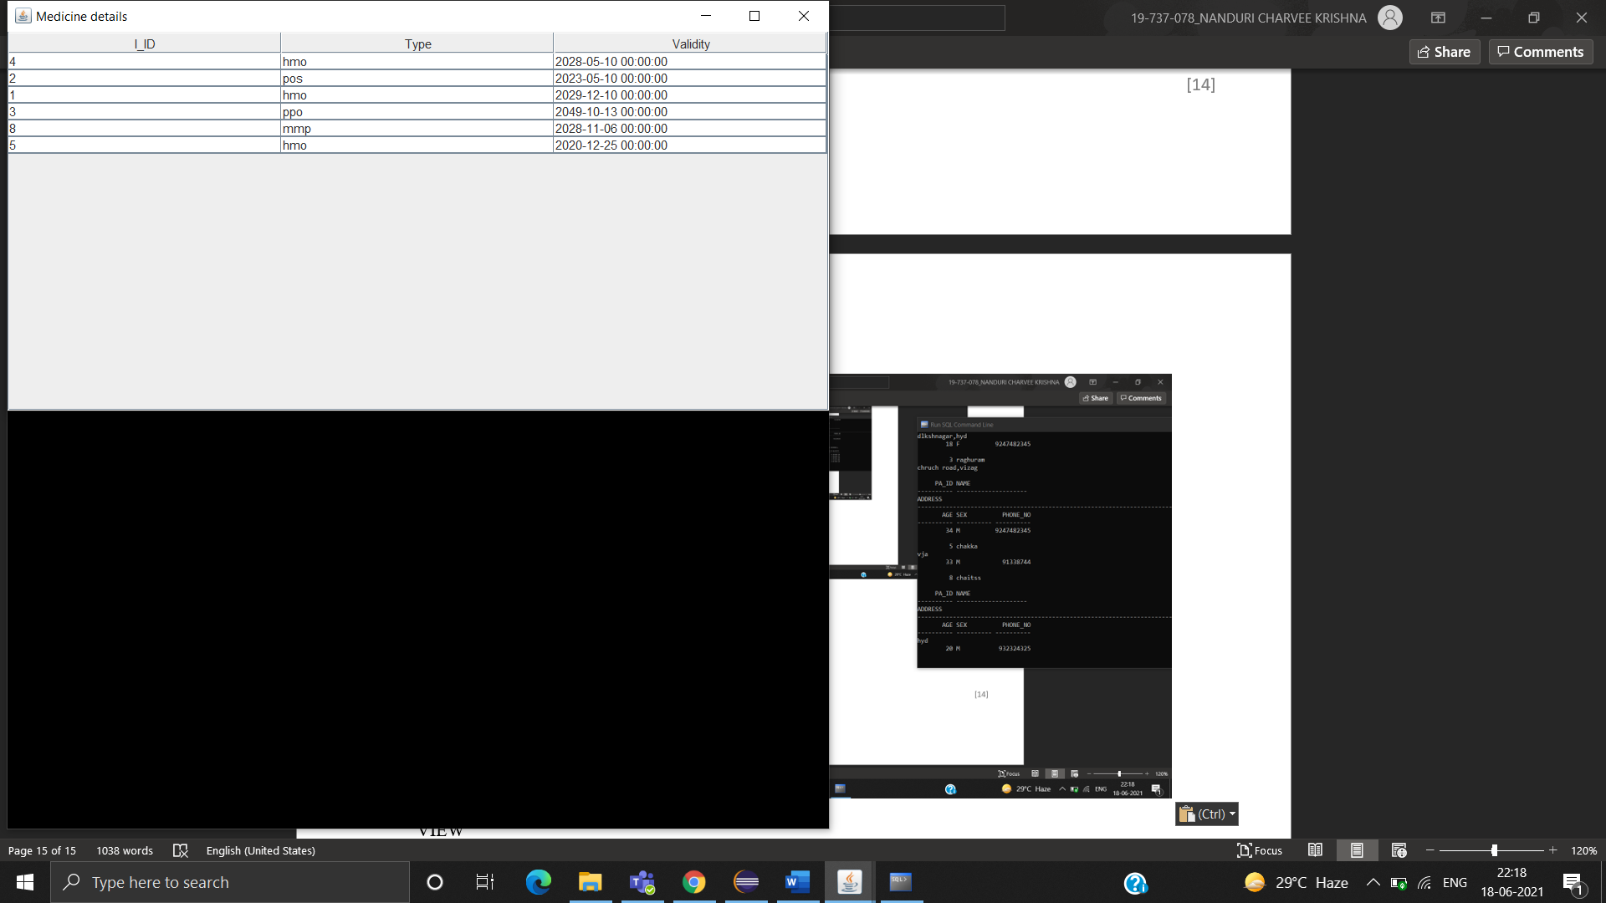

BILL TABLE

SUBMIT

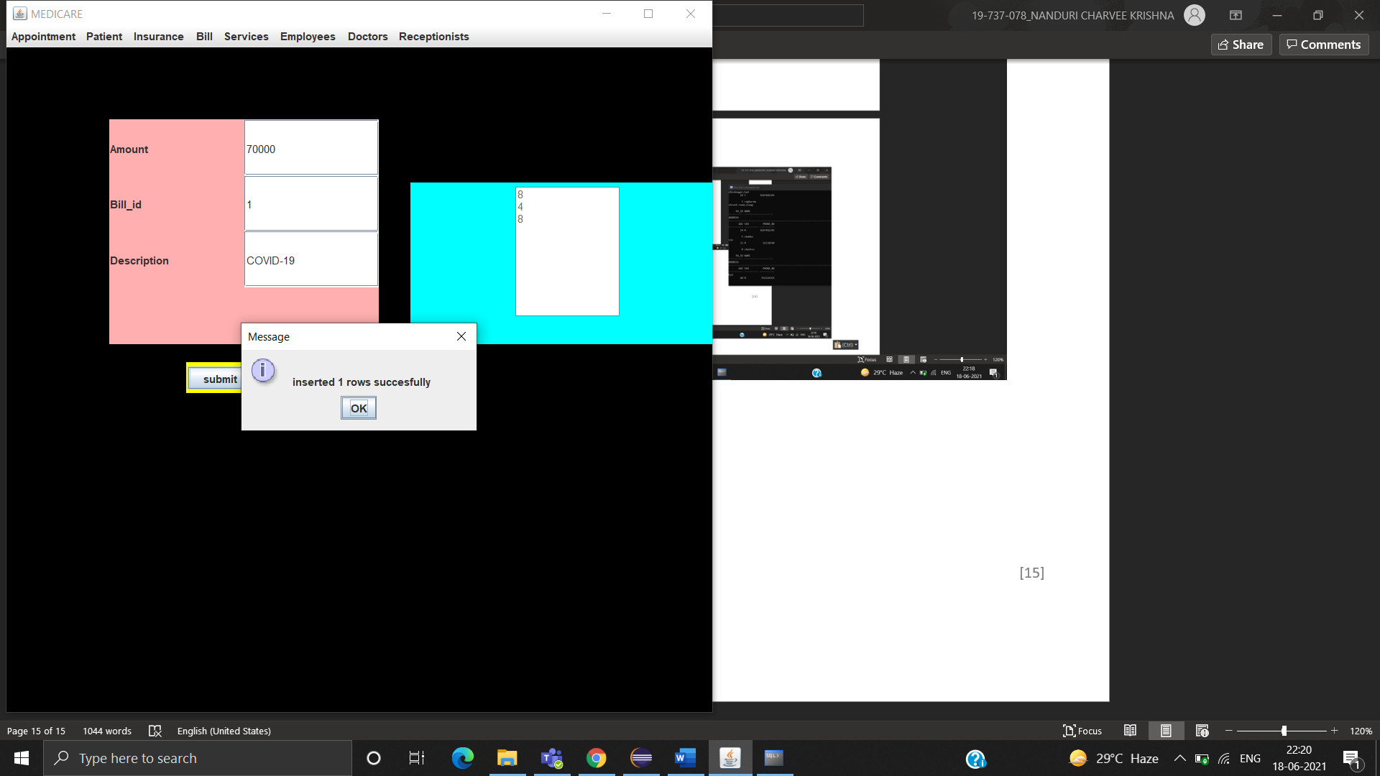

DELETE

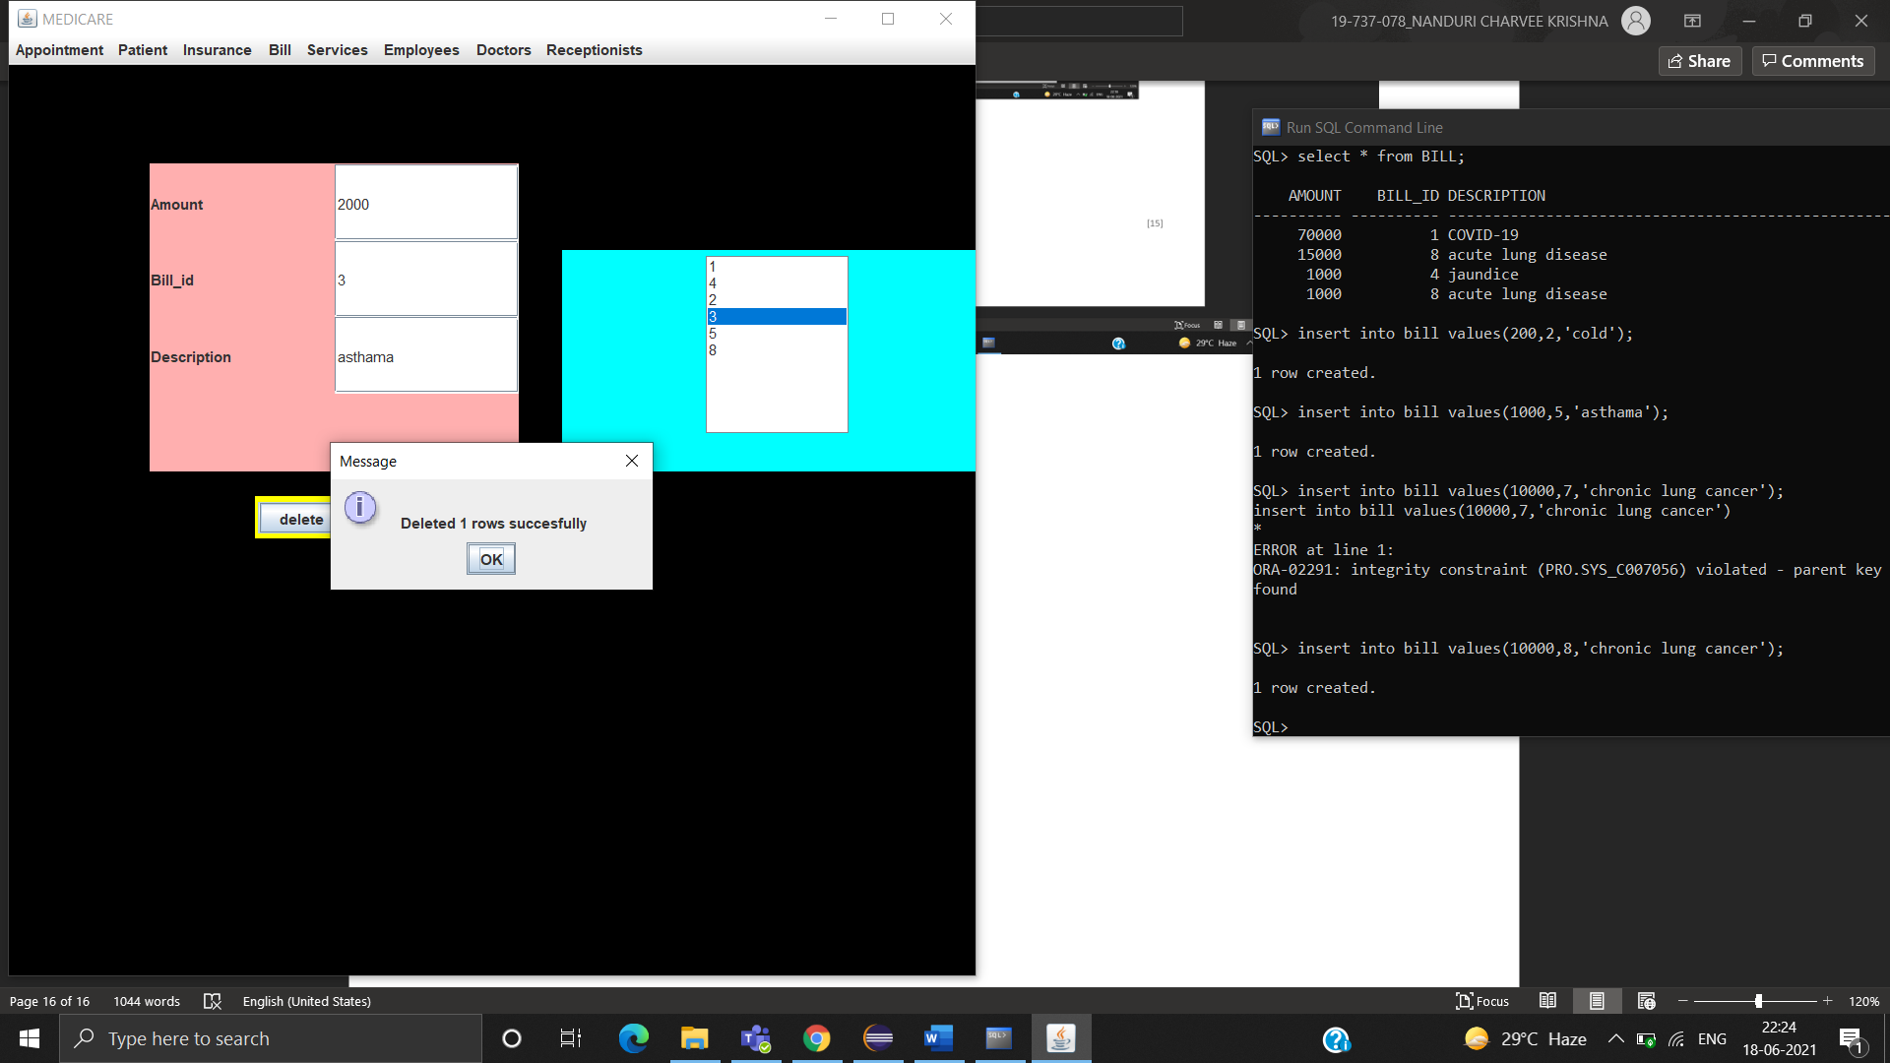

MODIFY

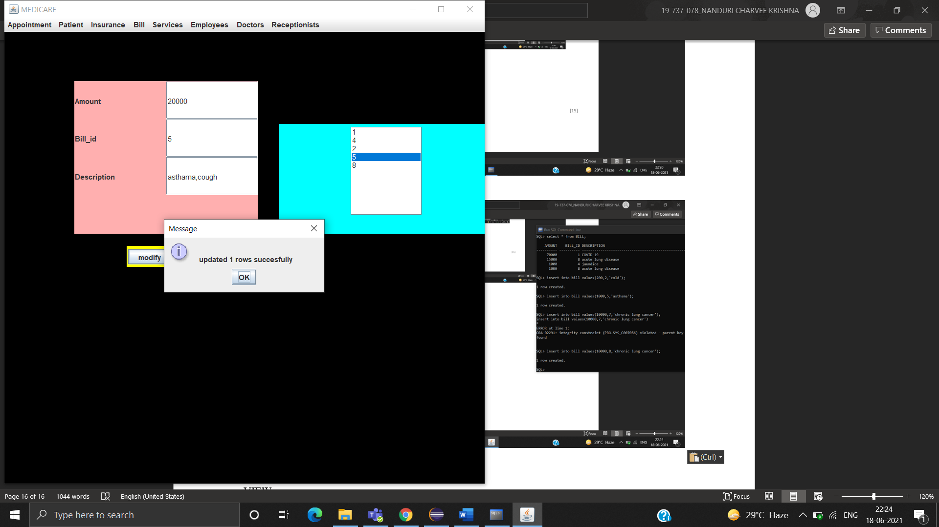

VIEW

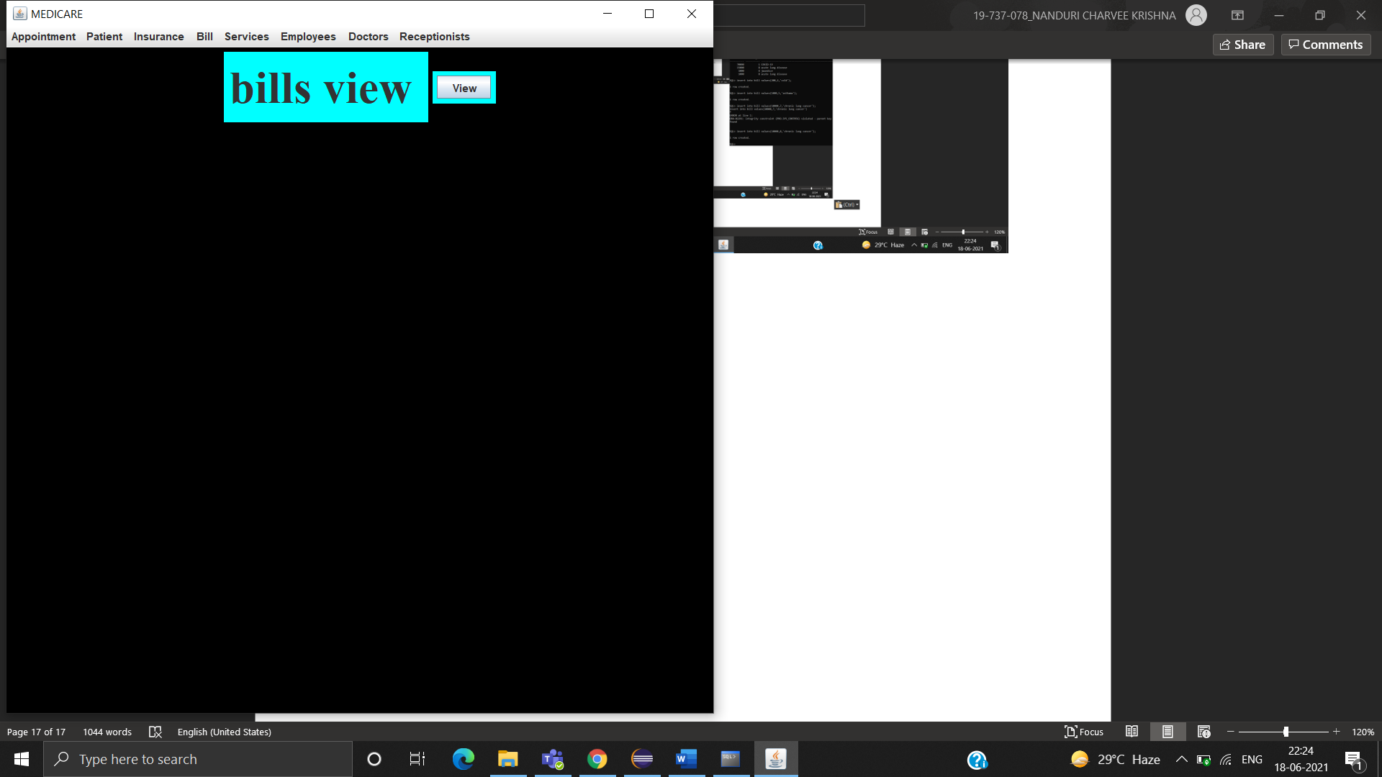

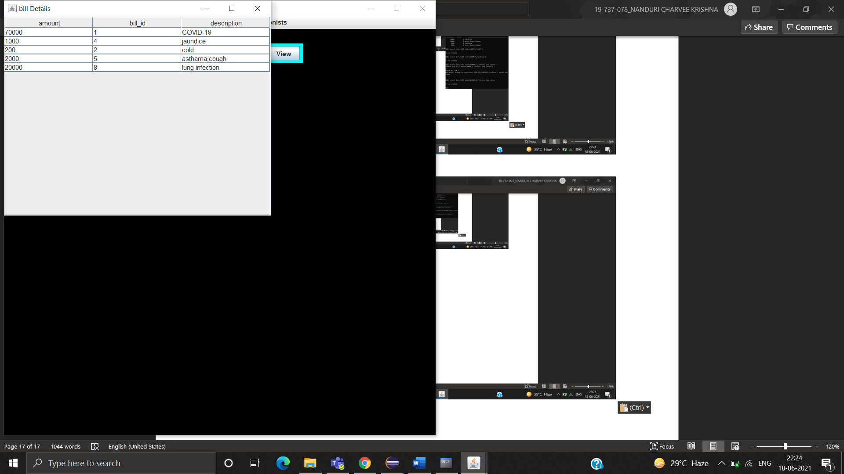

SERVICES TABLE

SUBMIT

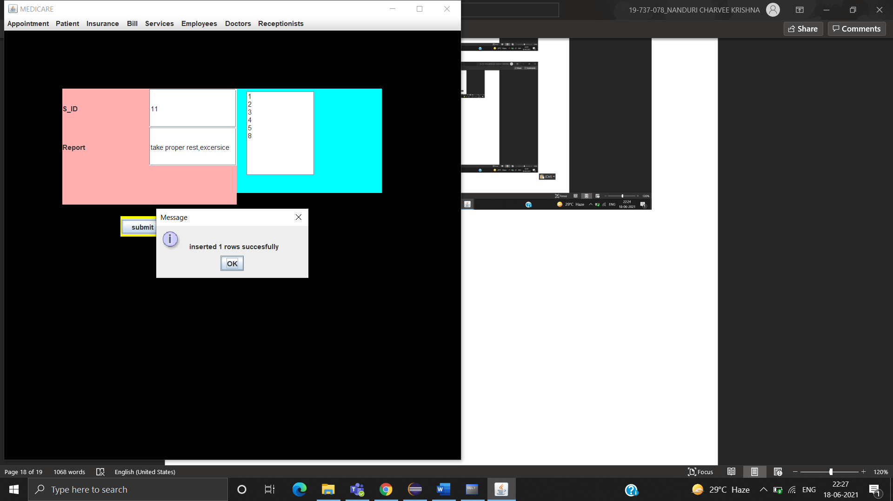

DELETE

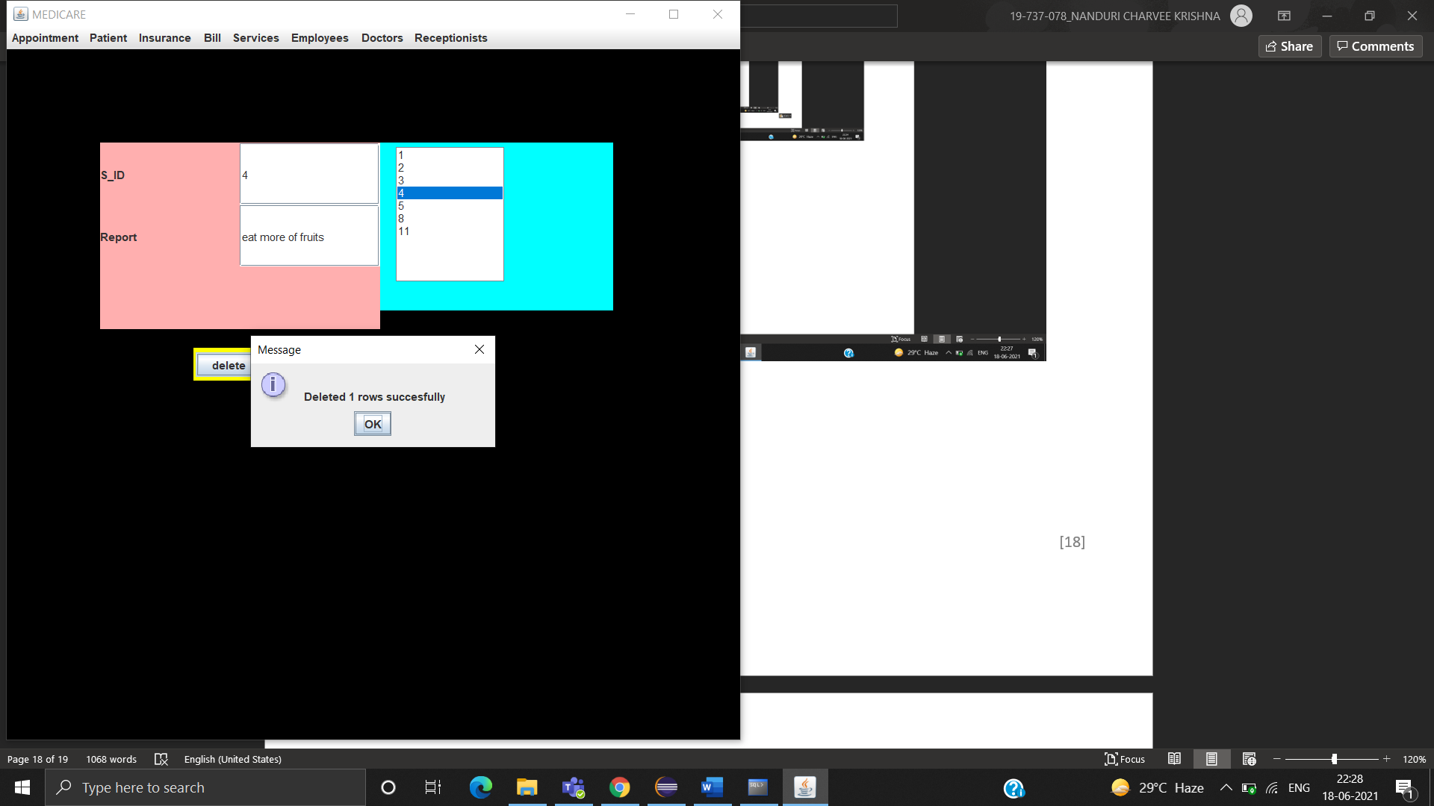

MODIFY

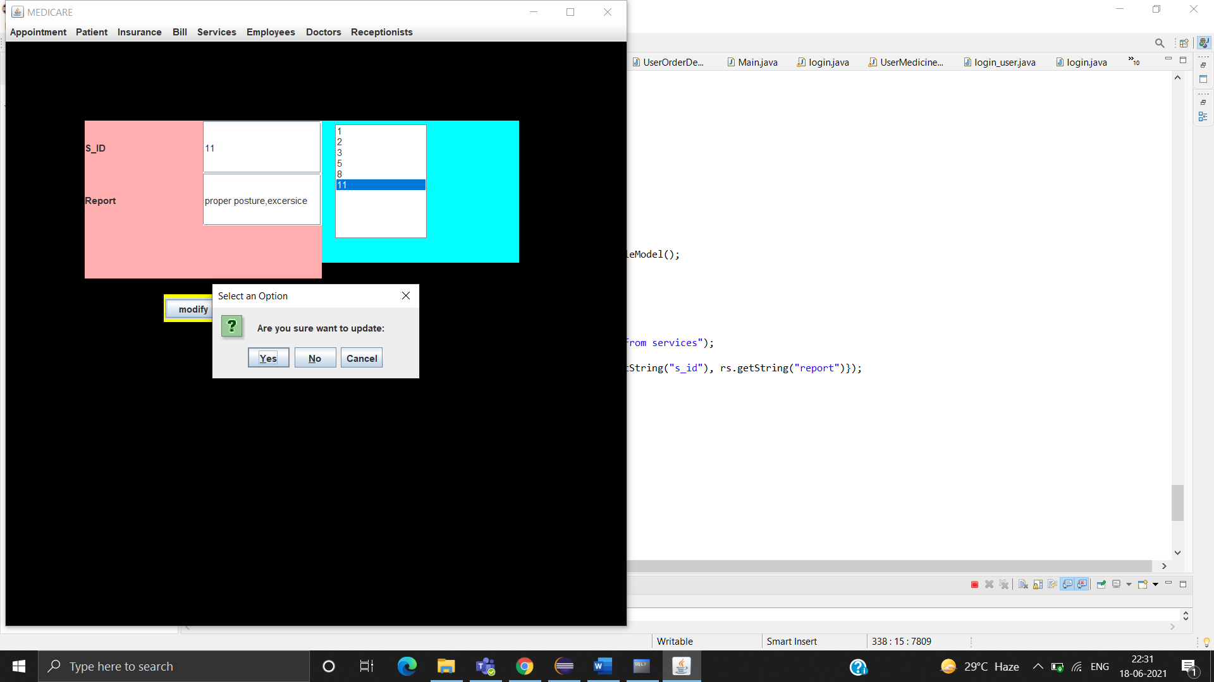

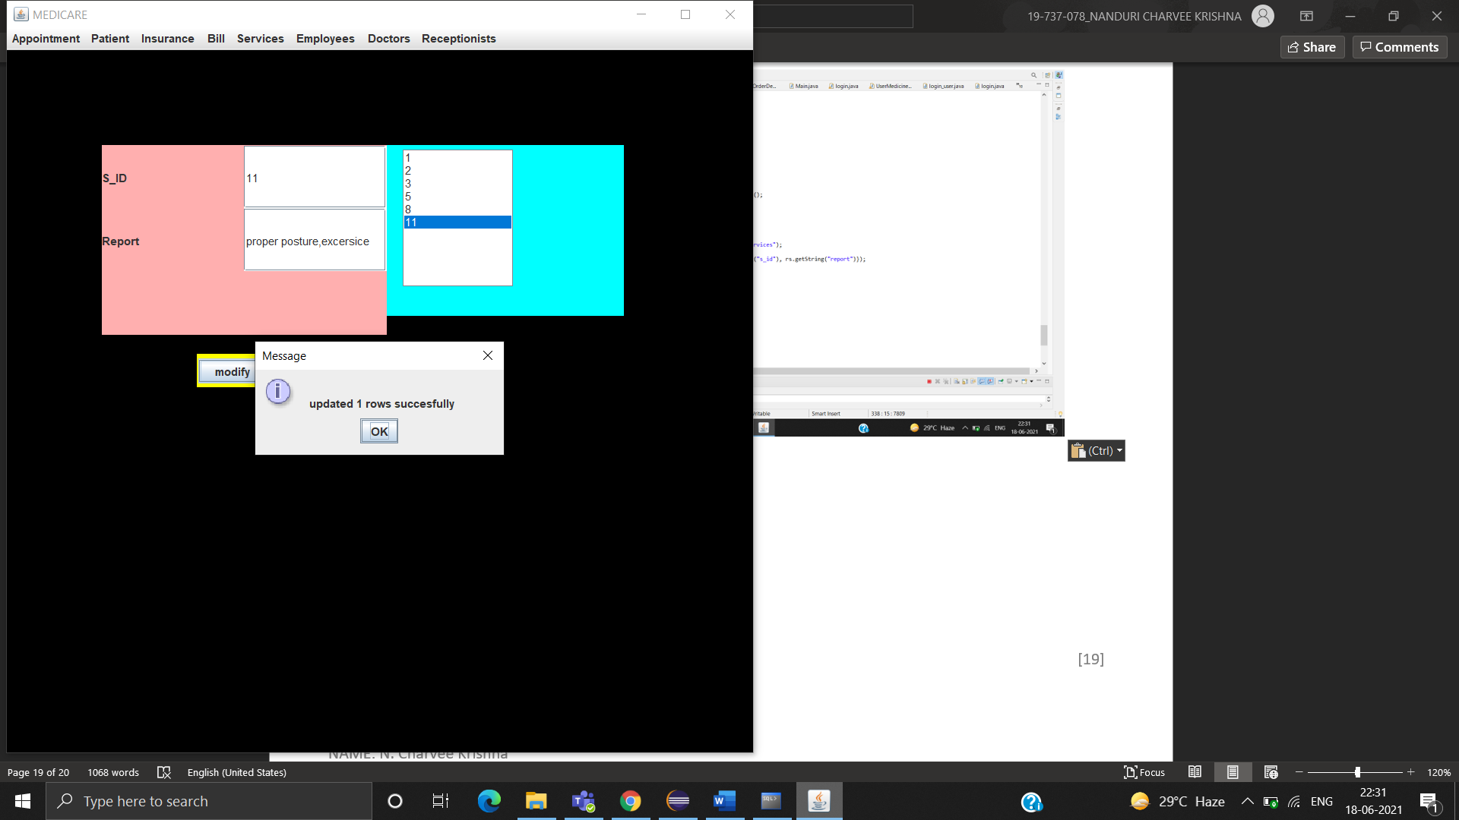

VIEW

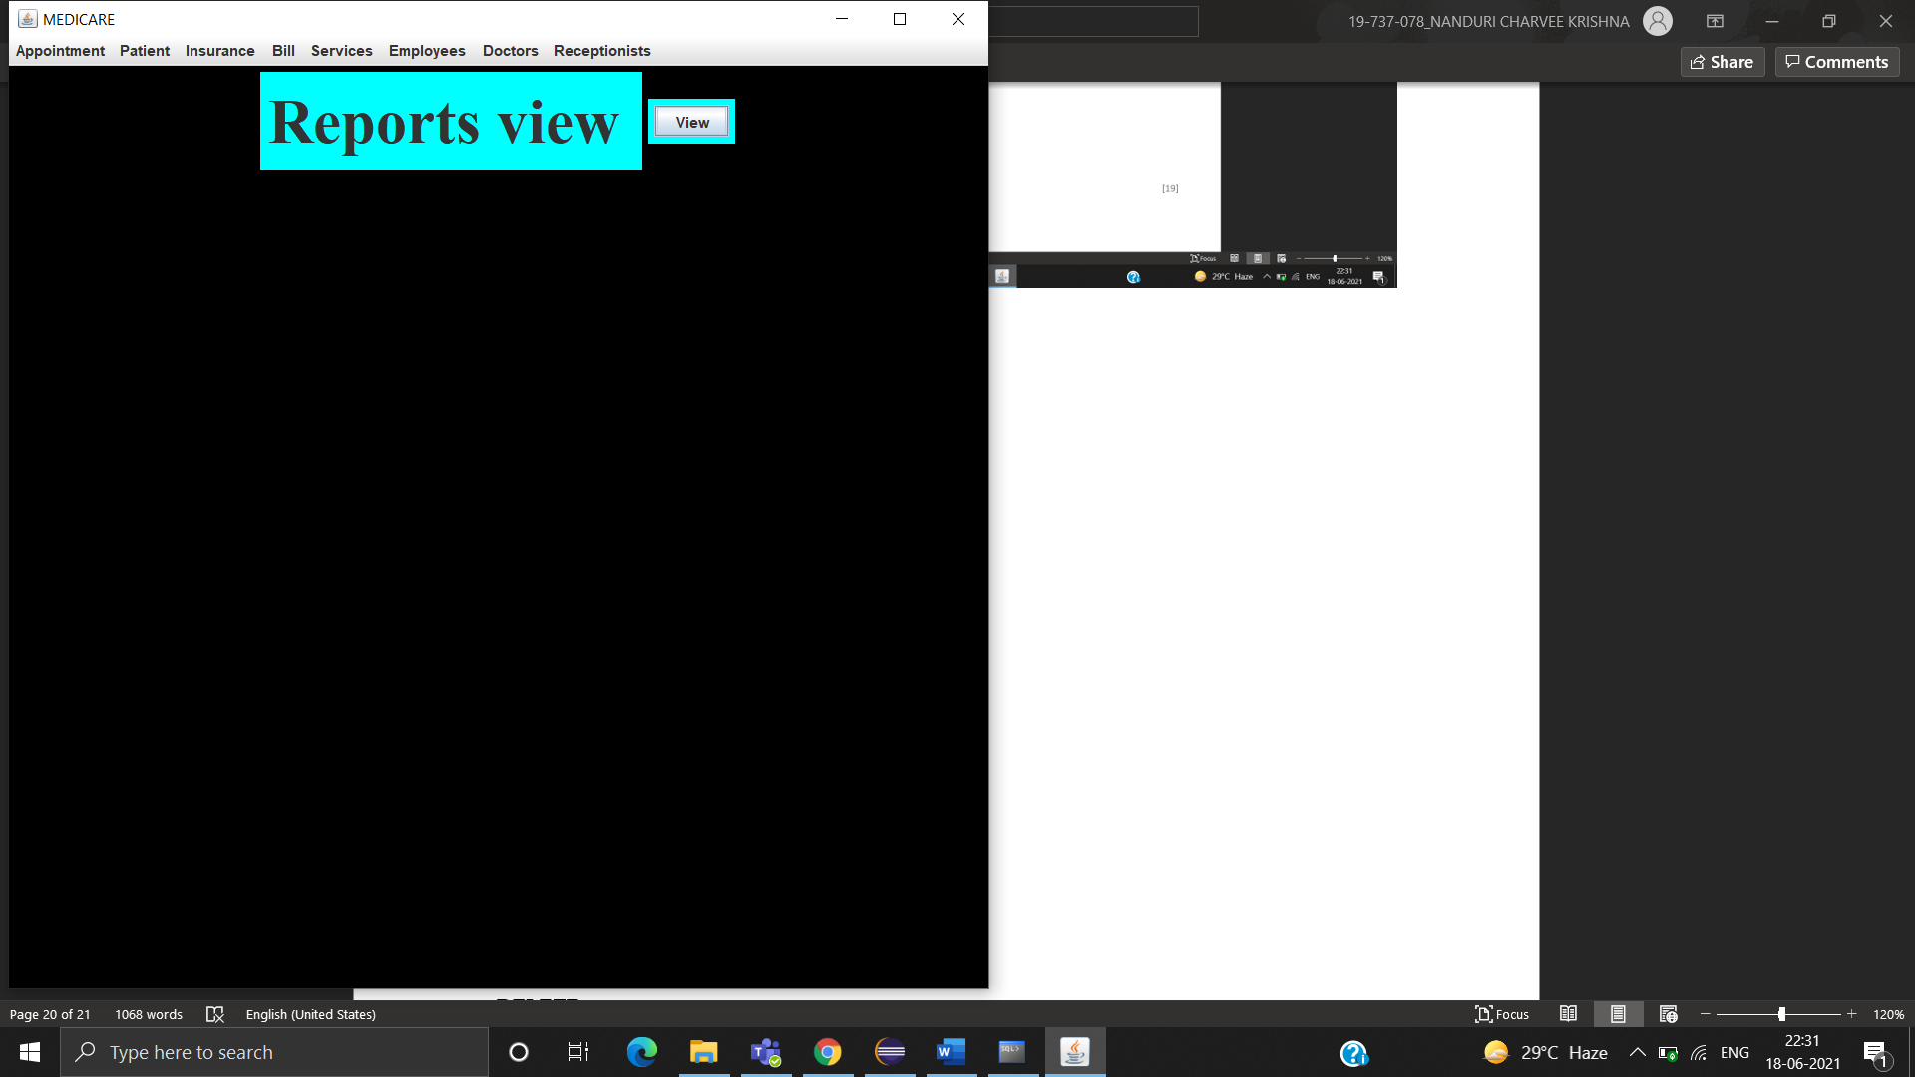

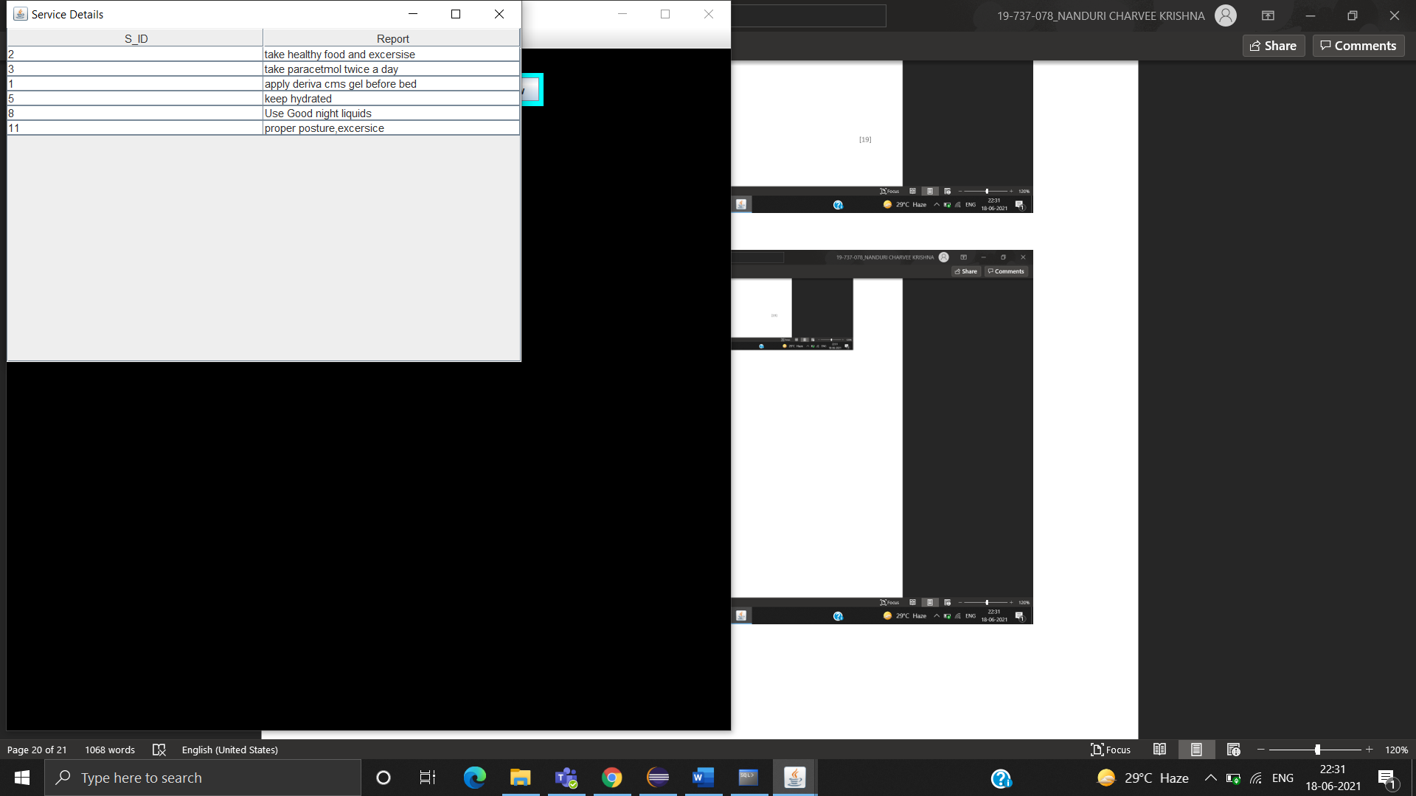

EMPLOYEE TABLE

SUBMIT

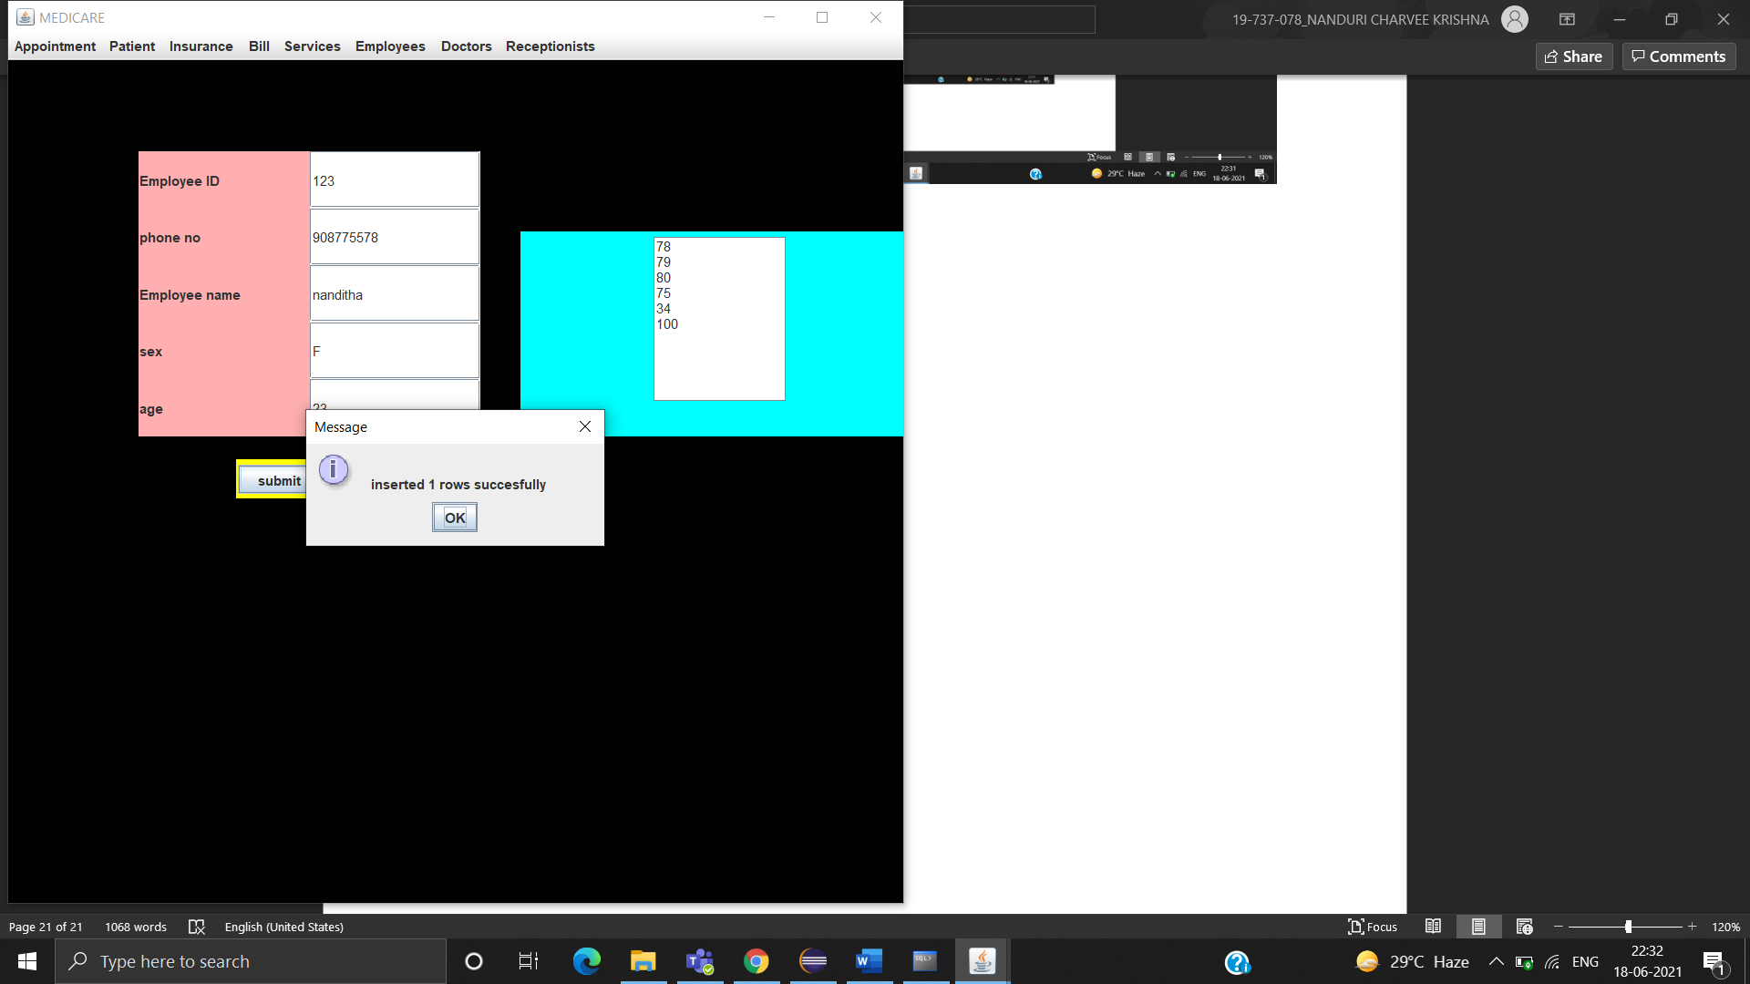

DELETE

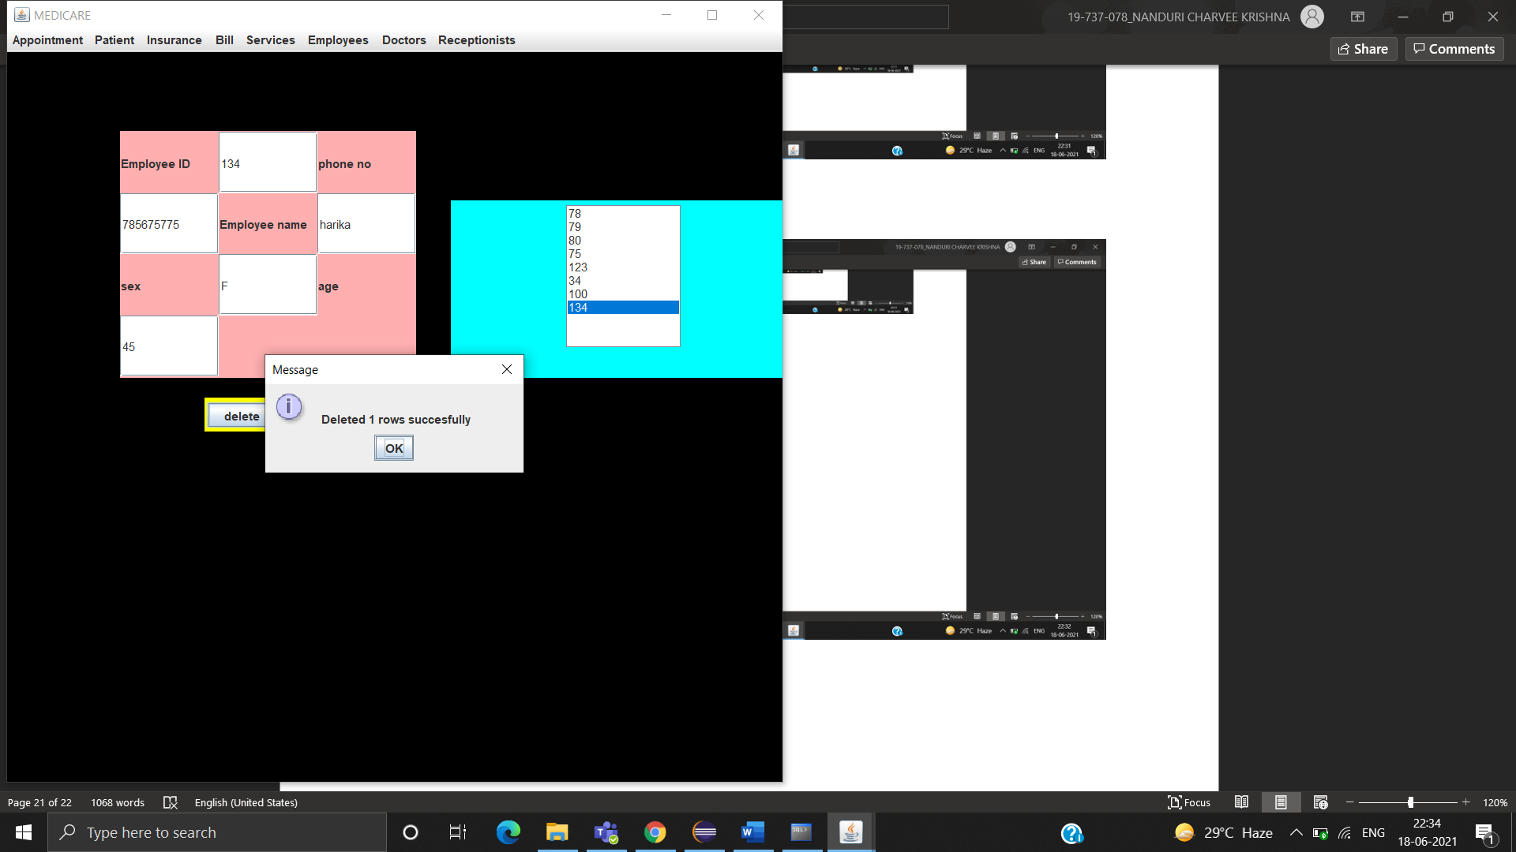

VIEW

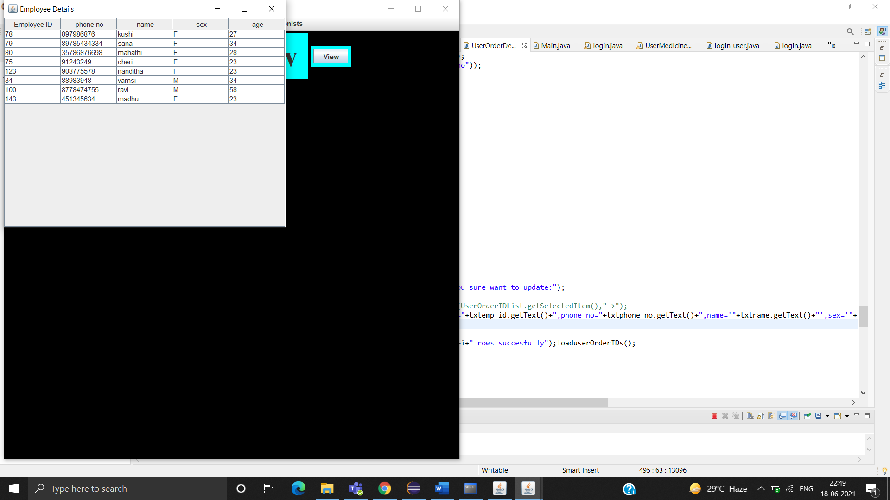

DOCTOR TABLE

SUBMIT

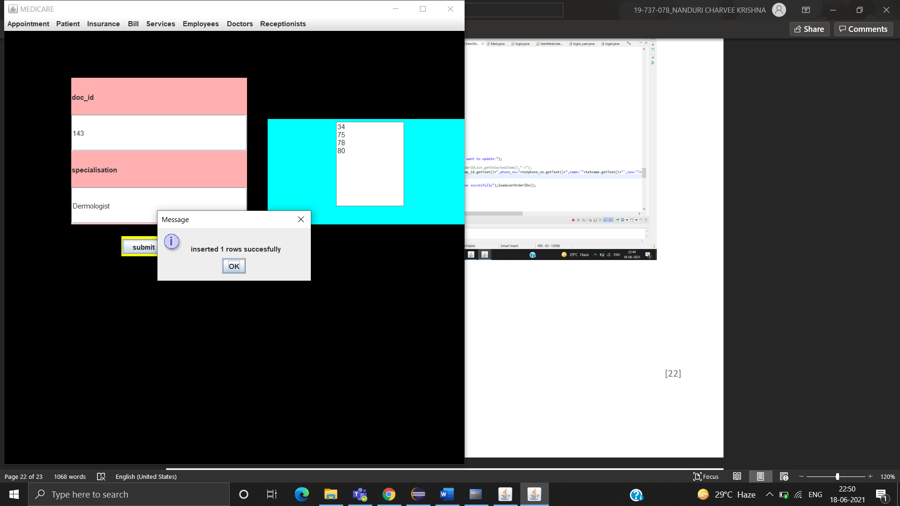

DELETE

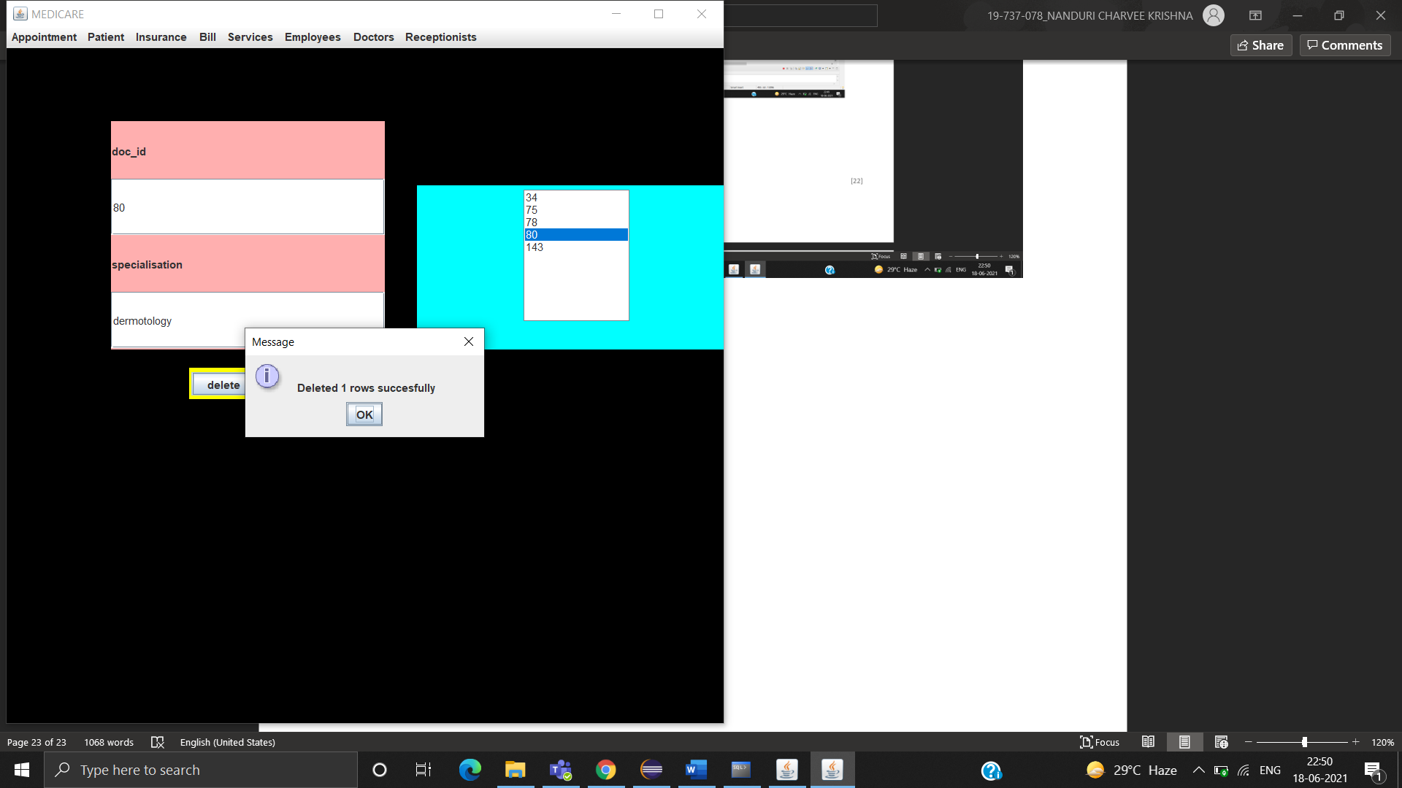

MODIFY

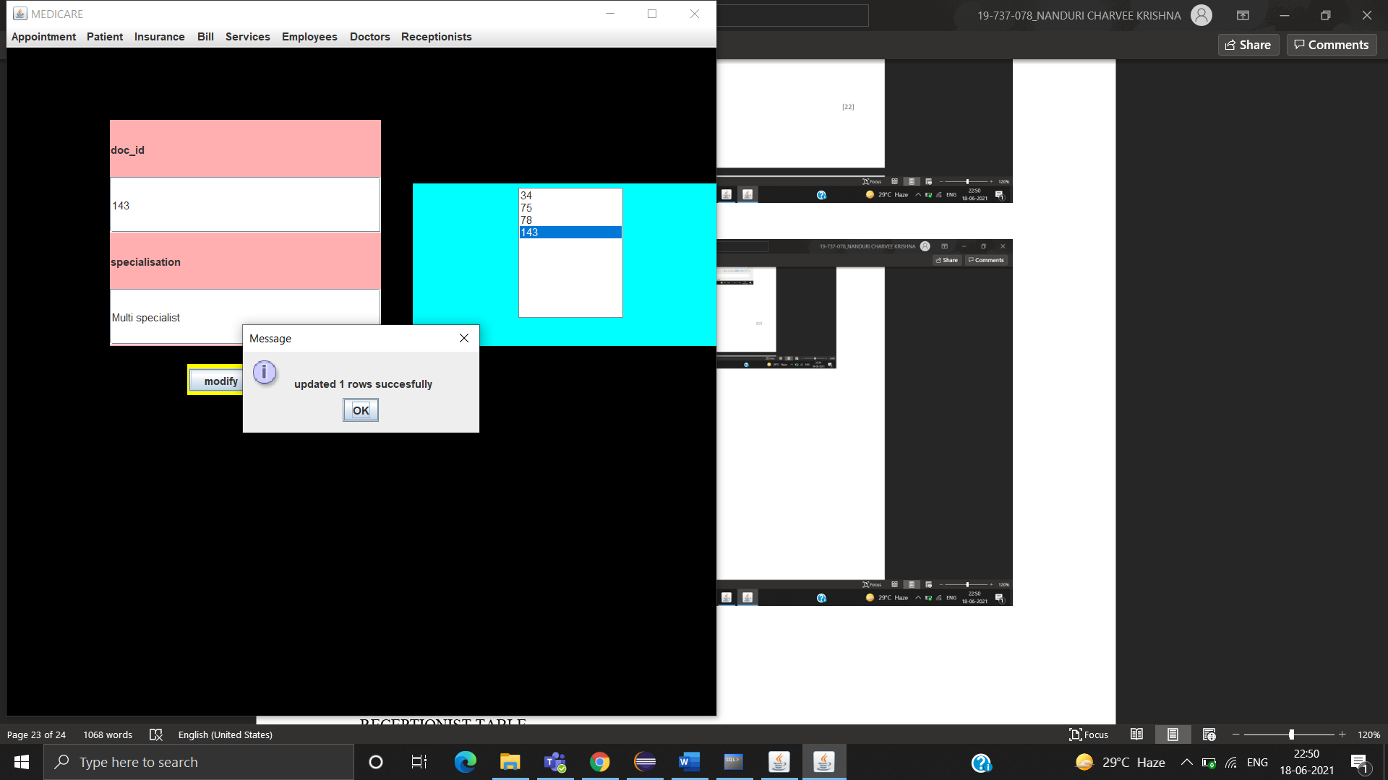

VIEW

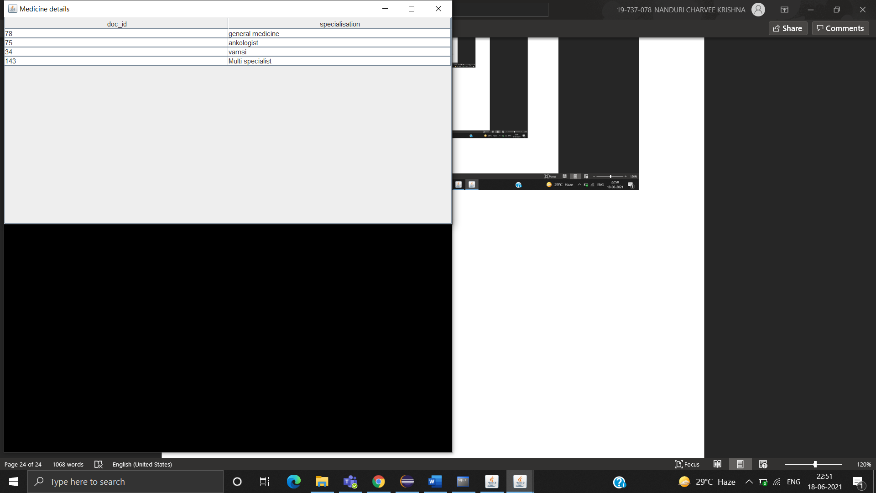

RECEPTIONIST TABLE

SUBMIT

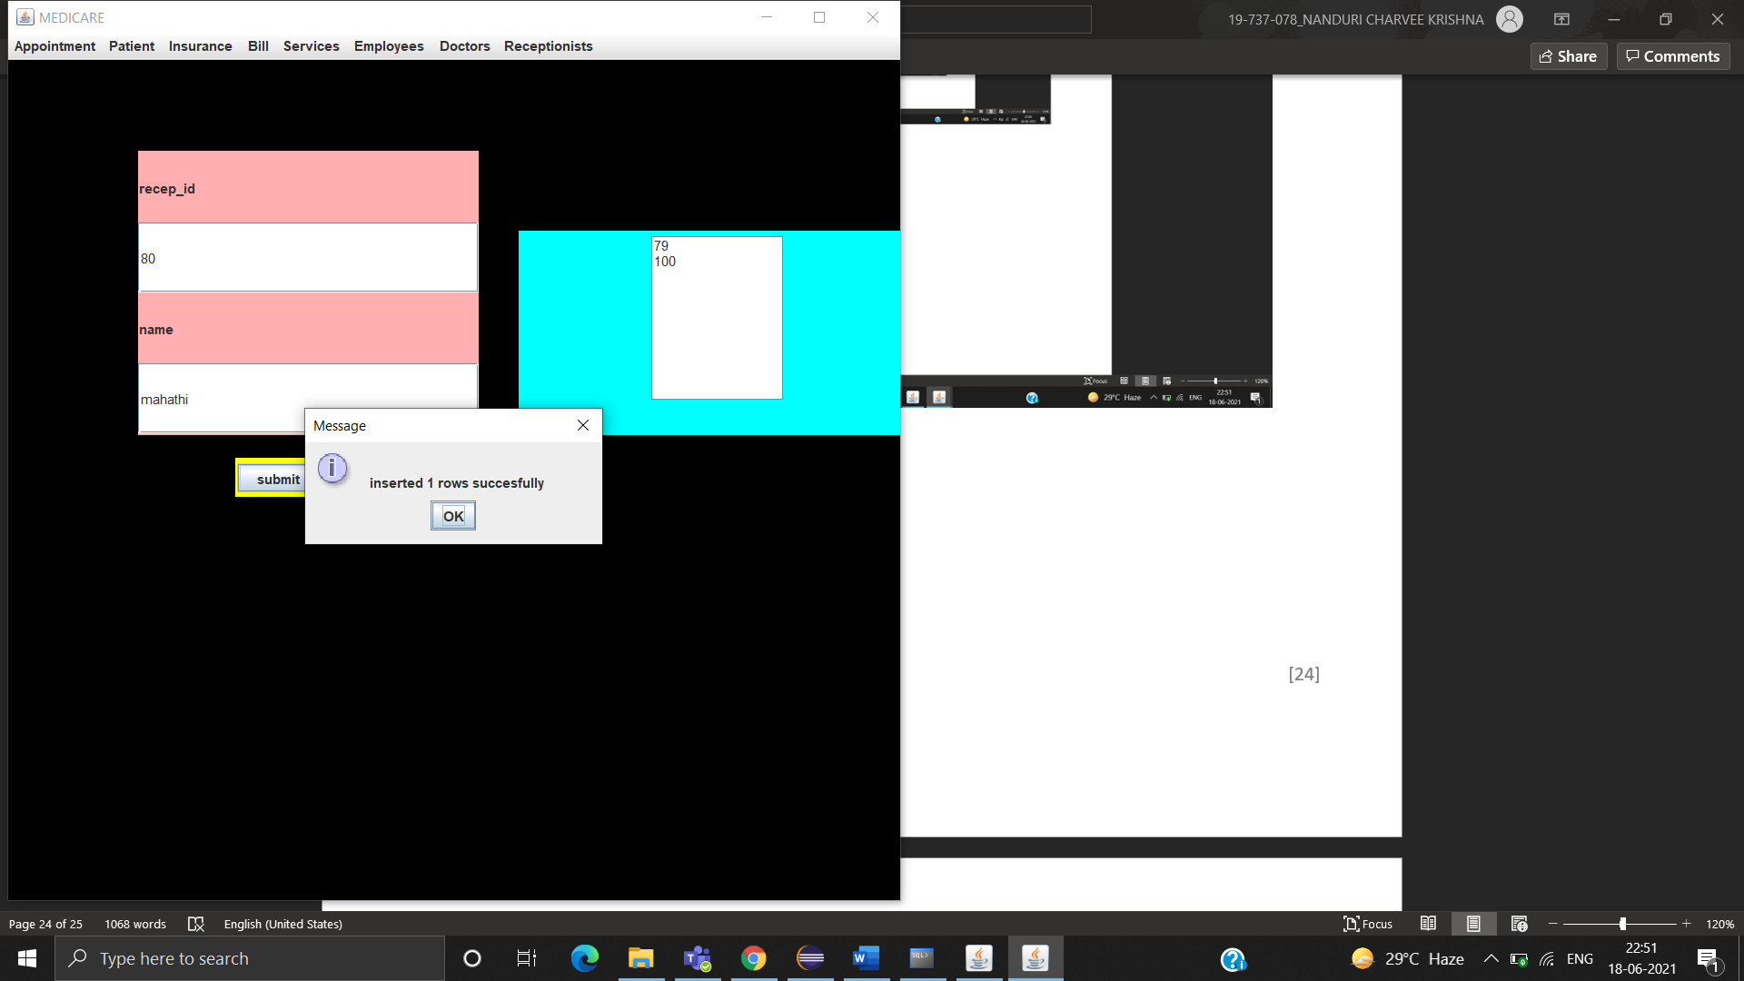

DELETE

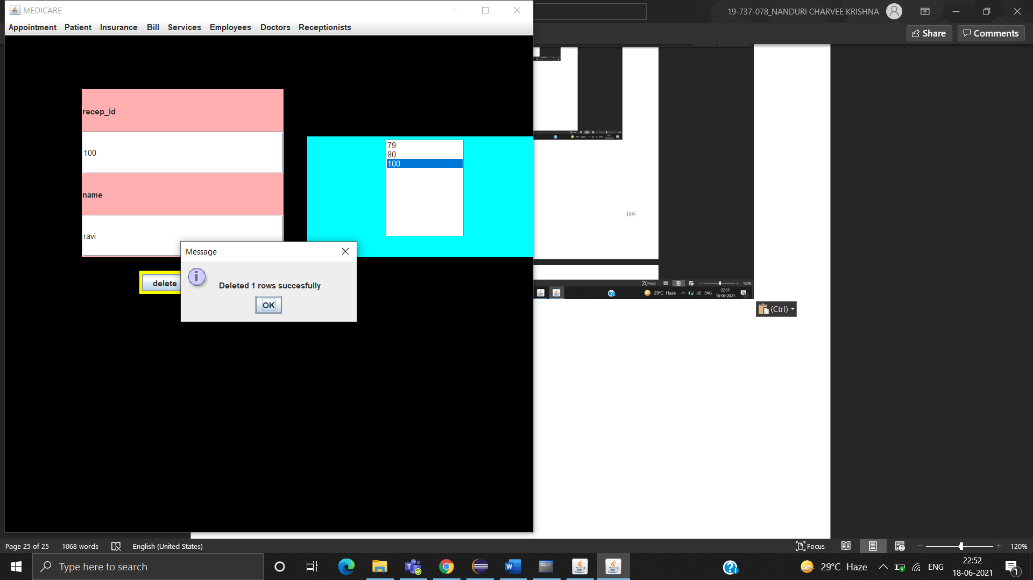

MODIFY

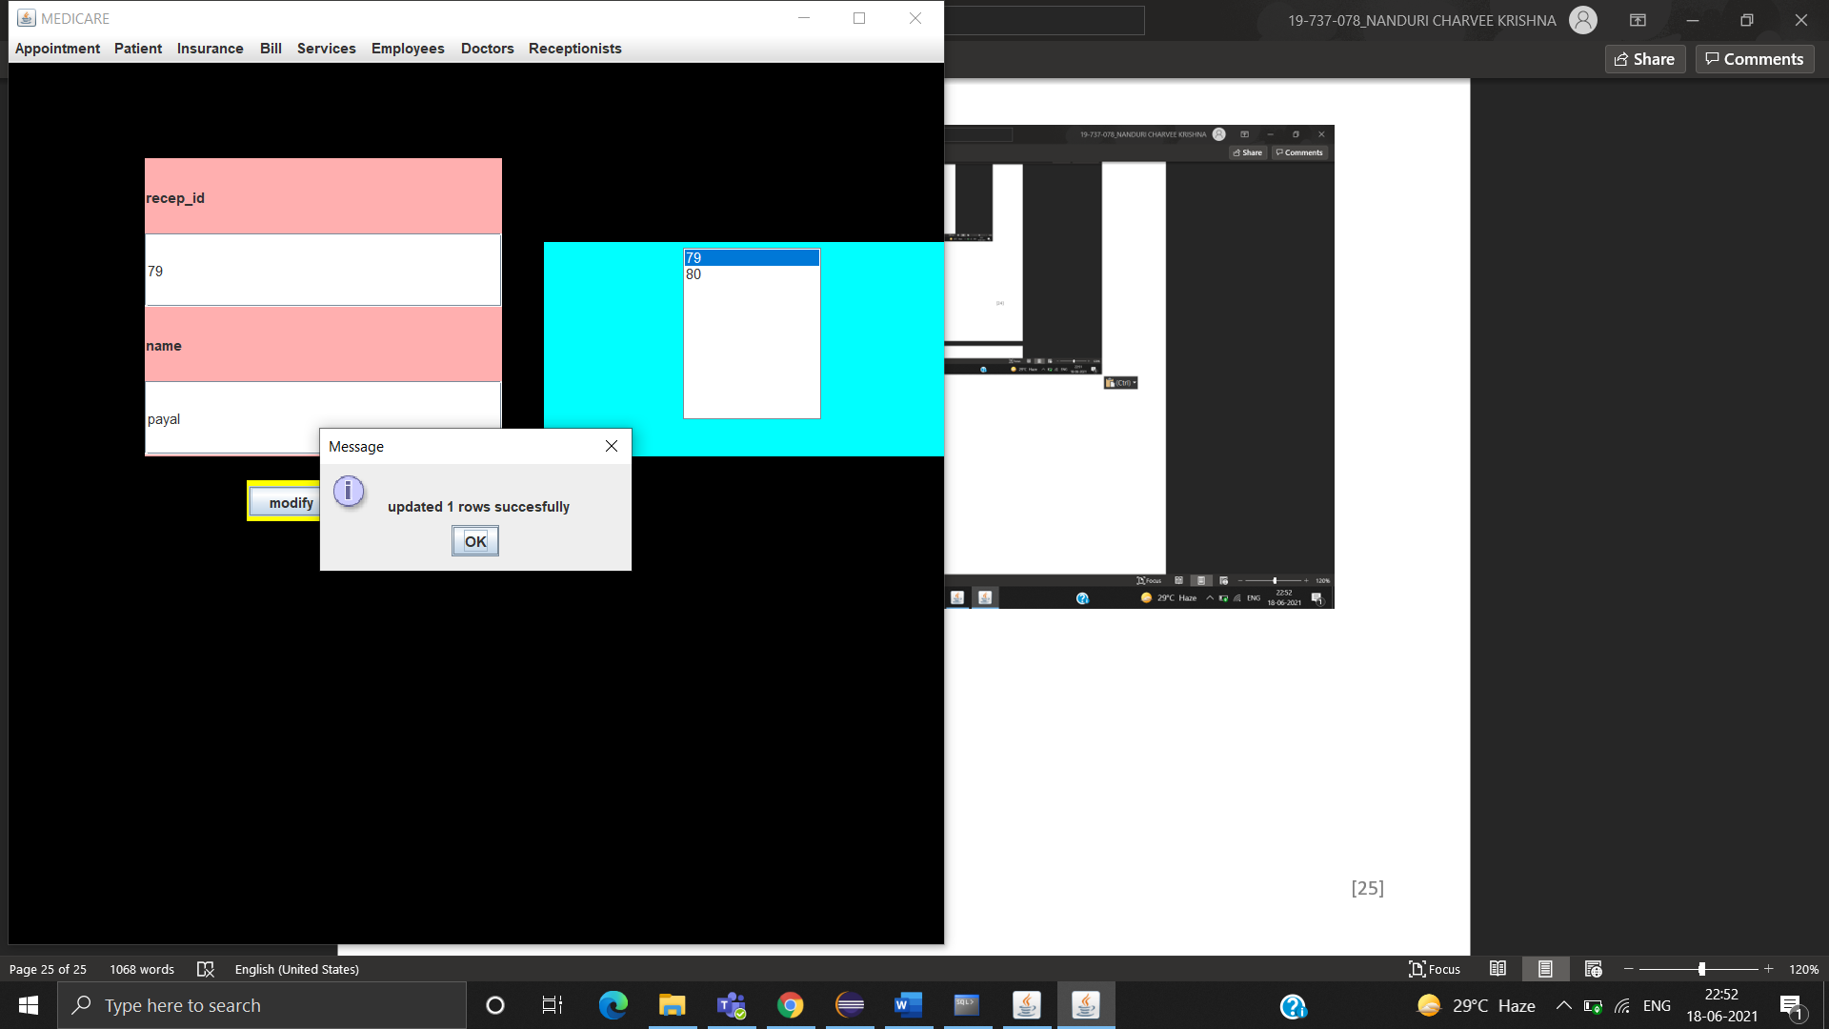

VIEW

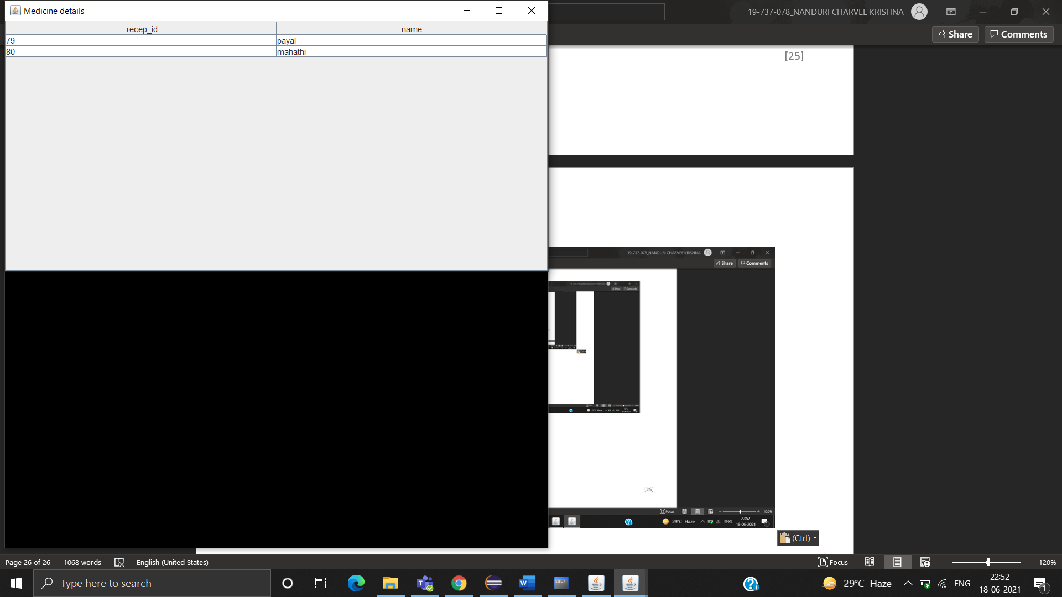

EXITING THE APPLICATION

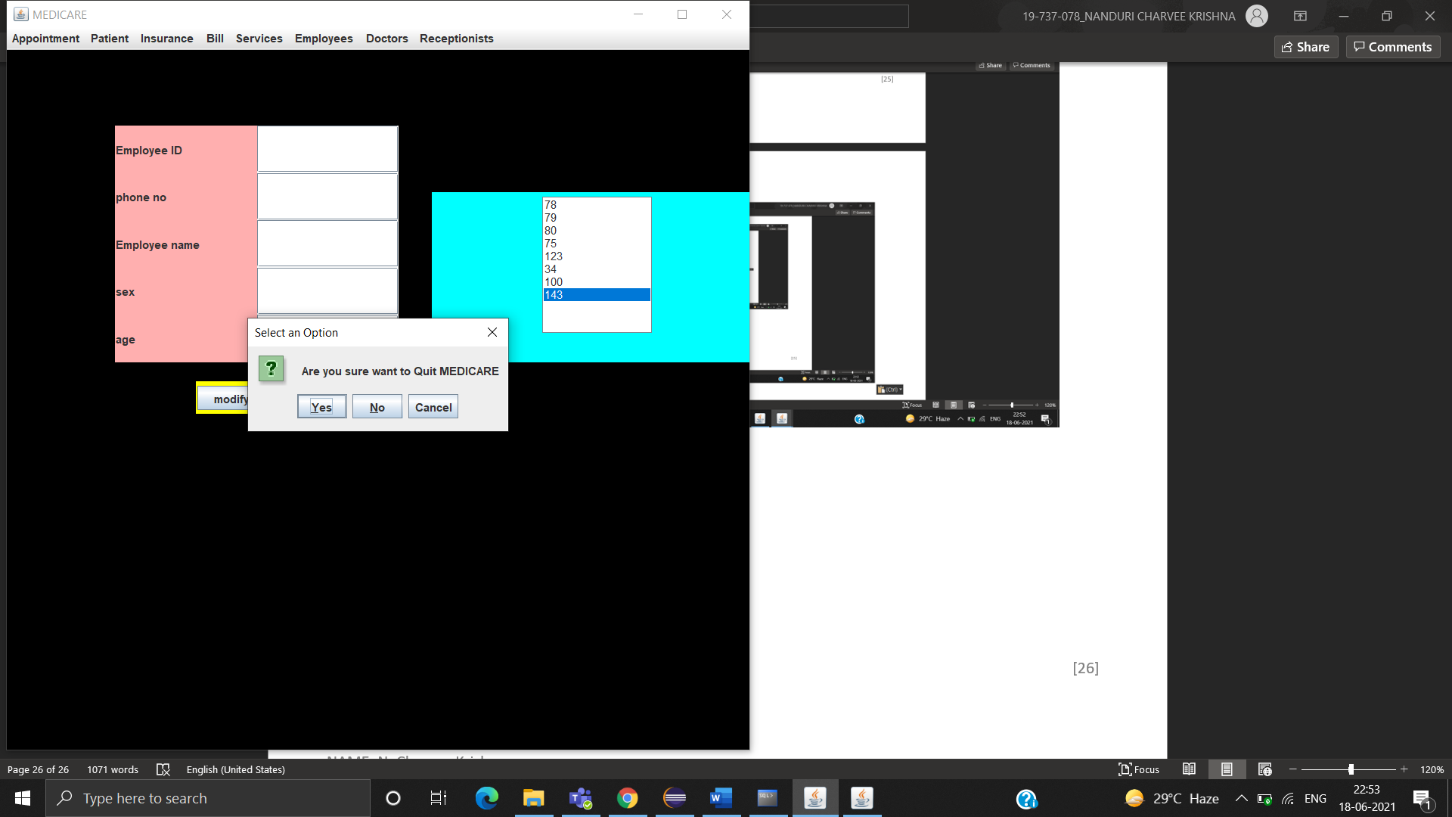

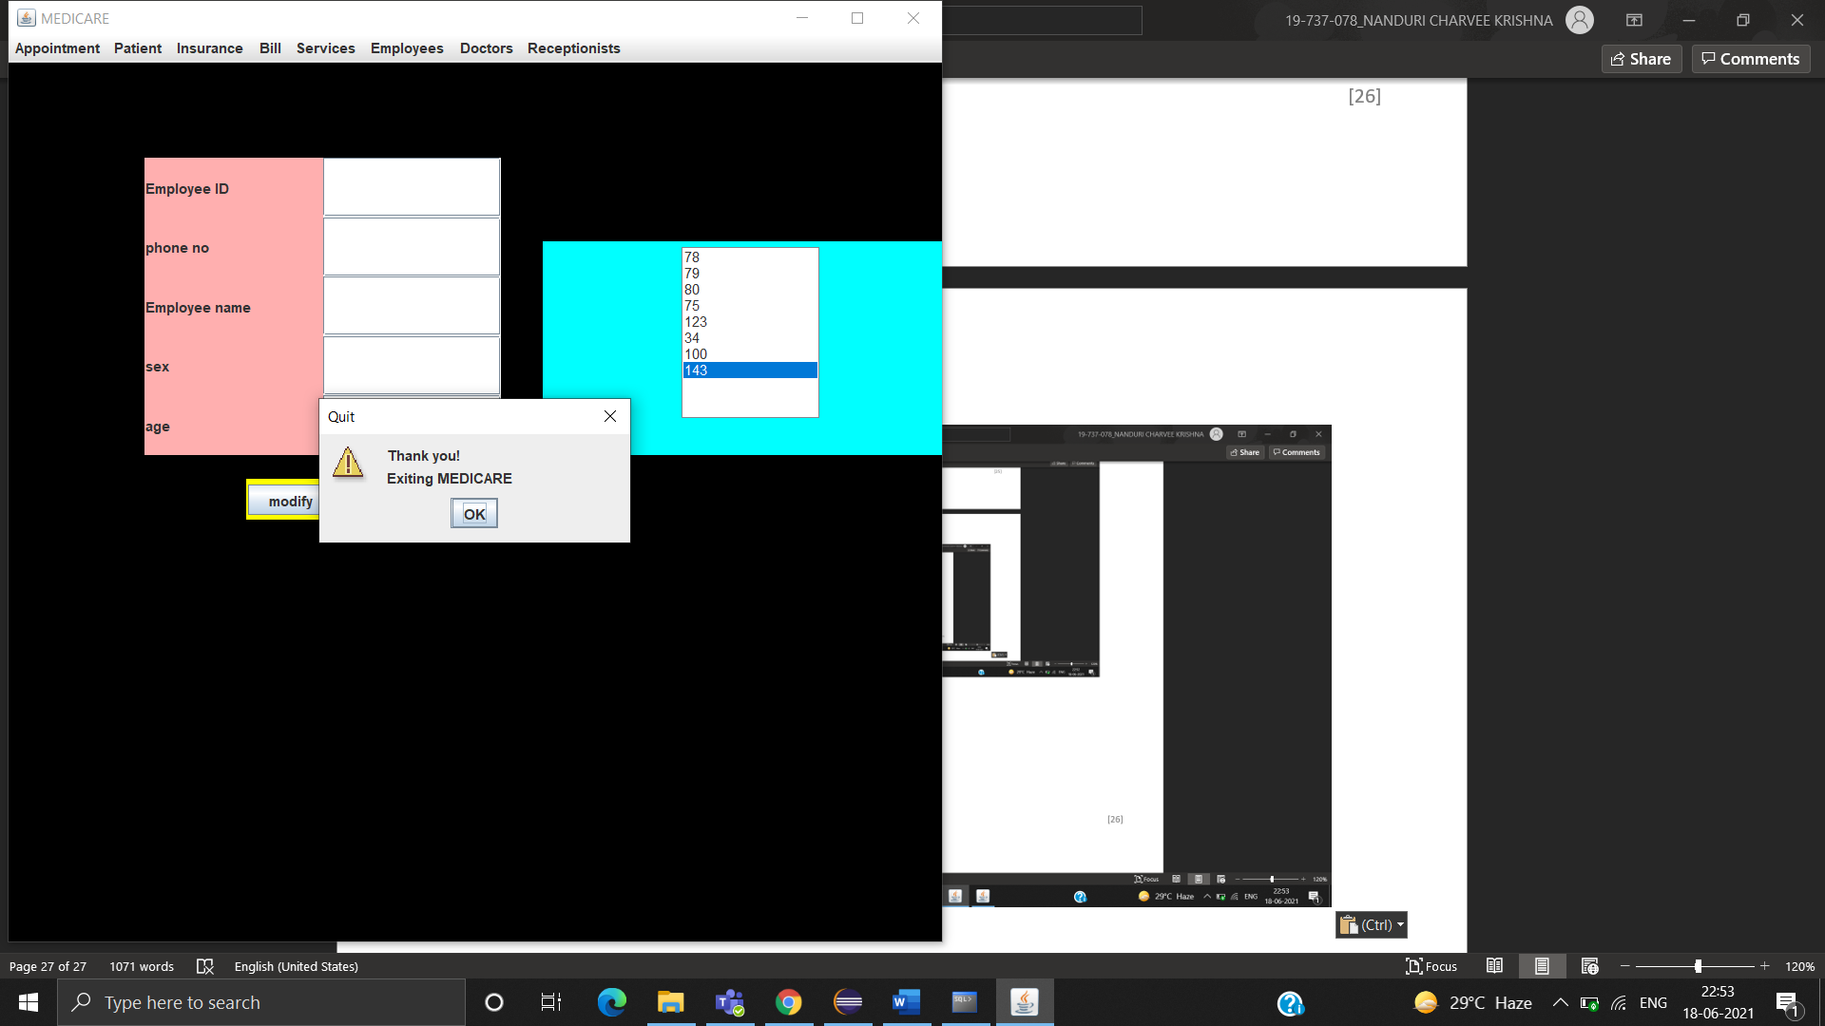

**The data entered in the above form is updated in the “service” table of the Oracle database 11g as:**

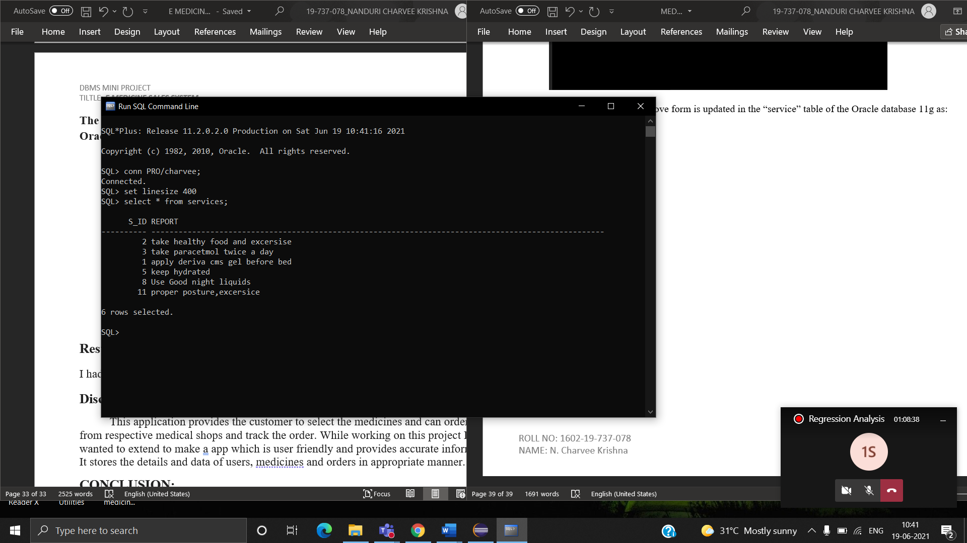

**The data entered in the above form is updated in the “employee” table of the Oracle database 11g as:**

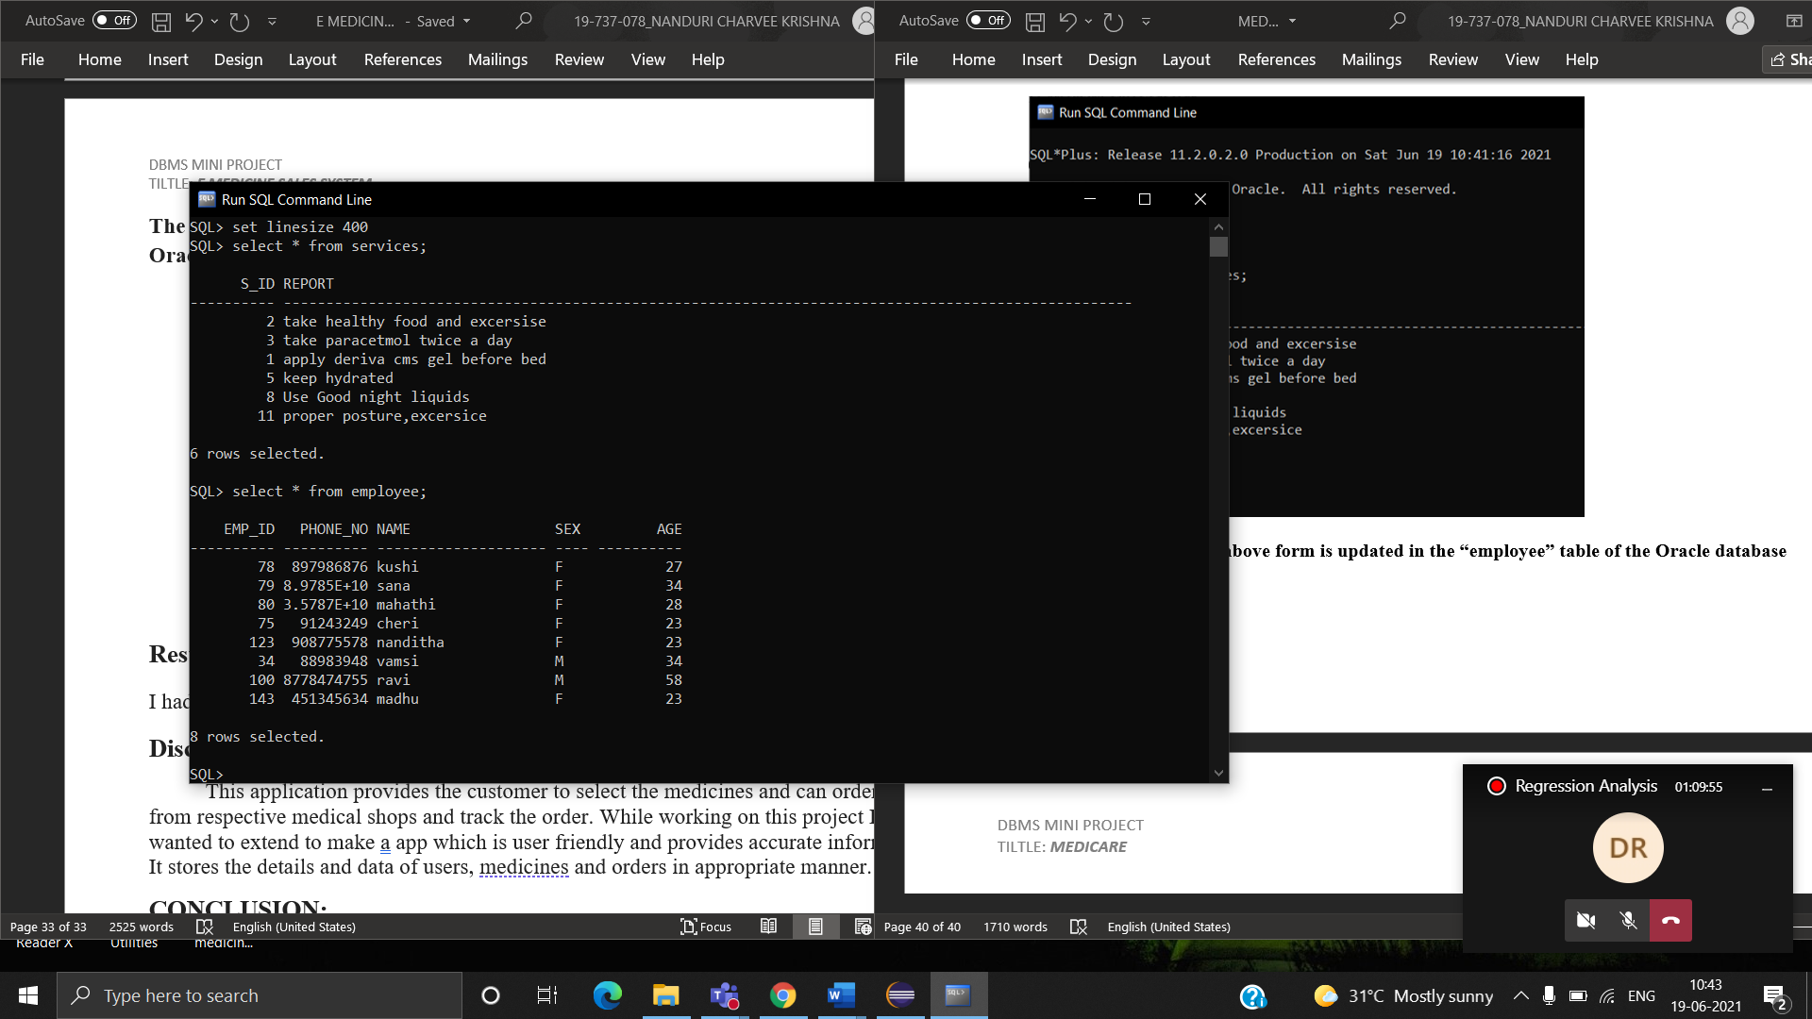

**RESULTS:**

I had successfully completed MINI PROJECT on “MEDICARE” (Hospital Management System)

**Discussion and future Work:**

This application provides the hospital admin to track all the appointments made and also employees working in the hospital . While working on this project I wanted to extend to make a app which is user friendly and provides accurate information. It stores the details and data of patients, insurance and bills in appropriate manner.

**CONCLUSION:**

Thus, a Java SWING based MEDICARE is created which is connected to the Oracle 11g database. Therefore, all the entries and details are directly updated on their respective tables created in the database.

REFERENCES:

* <https://docs.oracle.com/javase/7/docs/api/>
* <https://www.javatpoint.com/dbms-tutorial>